**CONTENTS**

|  |  |  |
| --- | --- | --- |
| CHAPTER NO | TITLE | PAGE NO |
| 1 | INTRODUCTION   * 1. PROJECT NAME AND OBJECTIVES   2. BACKGROUND OF THE PROJECT   3. OPERATION ENVIRONMENT | 1. – 5 |
| 2 | SYSTEM ANAYLSIS   1. SOFTWARE REQUIREMENTS SPECIFICATION 2. EXISTING VS PROPOSED 3. OPERATION ENVIRONMENT | 6 – 11 |
| 3 | SYSTEM DESIGN   1. TABLE DESIGN 2. DATA FLOW DIAGRAMS | 12 – 23 |
| 4 | SYSTEM IMPLEMENTATION   * 1. MODULE DISCRIPTION   2. DATA REPORTS | 24 – 71 |
| 5 | SYSTEM TESTING  5.1 UNIT TESTING  5.2 INTEGRATION TESTING | 72 – 73 |
| 6 | CONCLUSION AND FUTURE SCOPE | 74 |
| 7 | REFERENCES | 75 |
|  | SCREENSHOTS OF BUS TICKET MANAGEMENT SYSTEM | 76 – 85 |
|  | CONCLUSION | 86 |
|  | FUTURE ENCHANCEMENT | 87 |
|  | BIBILOGRAPHY | 88 |

**CHAPTER – 1**

**INTRODUCTION**

* 1. **PROJECT NAME AND OBJECTIVES**

Online Bus Ticket Reservation System is a Web based application that works within a centralized network. This project presents a review on the software program "Online Bus Ticket Reservation System" as should be used in a bus transportation system, a facility which is used to reserve seats, cancellation of reservation and different types of route enquiries used on securing quick reservations. OBTRS is built for managing and computerizing the traditional database, ticket booking and tracking bus and travel made. It maintains all customer details, bus details, reservation details. In order to achieve the design, Imo Transport Company (ITC) was chosen as a case study because of its strategic importance to Imo State. Structured Systems Analysis and Design Methodology (SSADM) was adopted. In addition, Visual Basic 6.0 (VB 6.0) language was used for the front-end of the software while the back end was designed using MySQL. The software achieved is capable of improving the customer hand and relationship management in ITC operations. It is recommended that despite the present functionality of the designed software, an additional functionality such as the use of E-mail to send tickets and notifications to the customer and an online payment using credit cards/debit cards should be implemented into the system. Furthermore, other operations carried by ITC such as the courier services should also be integrated in order to enhance the system.

**OBJECTIVES:**

The Bus ticket reservation system is currently maintaining the project Transport Company’s process manually which is a very time consuming process. It deals with transport industry’s ticket booking and transport maintenance, so it becomes a very tedious job for the ticket booking transporter to look after these particulars to complete the task at right time. The bus ticket booking system not only deals with transporters owned vehicles but also takes into consideration about the other types project of system transport vehicles available with other transporters .

* To develop a software application that supports Specific to the project Travel Agency Automation that can solve all tedious tasks related to ticket booking in a travel agency.
* This system will lead to increase in the ticket booking efficiency of the project Staff and members of the Ticket Booking Agency with little throughput.
* This system project is made as user friendly as possible so that any one can use it with little knowledge of system computers.

* The ticket booking project will reduce the ticket booking tedious job of system paperwork by keeping all the project details of bus ticket booking, cancelling tickets are stored in the form database in computer’s hard disk.
* Up-to-date information of the system Performance status and other enquires.
* We provide up to date information that is not possible manually.
* The objective of my project is to make easy the ticket booking project system of Ticket Booking Agency simple, reliable, user friendly, and corrective. Moreover less time consuming as compared to manual work.

The main objective of the project entire activity is to automate the ticket booking process of day to day activities of system Library like:

* Ticket activities.
* Creation of a Customer id.
* Assign a bus Tickets according to customer’s **demand.**
* Advance bookings.
* BusTicket Cancellation.
* Feedbacks.
  1. **BACKGROUND OF THE PROJECT**

Tourism is a big growth business in all countries. Bus Reservation System deals with maintenance of records details of each passenger. It also includes maintenance of information such as timetable and details in each bus.

The prevalent view in various global circles is that man is presently living in an age growth of information gathering, processing and dissemination, popularly called the information age. For this reason, managers and other users ofinformation especially in transport industries are demanding more kinds of information to support management and operations. They must therefore respond to the increasing requirement for information and data management.

Electronic tickets, or e-tickets, gives evidence that their holders have the permission to enter a place of entertainment, use a means of transportation, or have access to some Internet services. The design of this online system will be beneficial to the company because it has not existed before. Therefore, Imo Transport Company, Owerri, a viable investment owned by the state government whose primary objectives are: to spread comfort and hospitality to passengers away from their home, to make profit, will definitely appreciate a system which can automate its manual operations in the area of bus ticket reservation in order to meet customers increasing demand during peak and off peak seasons.

The ultimate expectation is to inspire a feasibility study aimed at providing proper guidance and awareness to any future potential investors, particularly those in the bus industry, to consider utilizing the Imo transport, as a gateway to the fertile soil of unlimited opportunities in the south-east Nigeria. Currently, staff at the bus ticket counter is using an internal system to sell tickets at the counter and customers who are unable to buy bus ticket online at this moment would have to go to the counter to a buy bus ticket.

Sometimes, customers’ needs to queue up a long queue to buy bus ticket and ask for information and this brings a lot of inconveniences to customers. However, Online Bus Ticket Reservation System enables the customer to buy bus ticket, make payment, and ask for information online easily. Furthermore, staff cansell bus ticket using Bus Ticket Reservation System after checking the bus ticket availability for the customer and print the bus ticket to the customer.

Currently, the type of system being used at the counter is an internal system which is manually used in selling the bus tickets. The problems facing the company are that customers have to go to the counter to buy bus ticket or ask for bus schedule, customers will also have to queue up for a long time in order to secure a bus ticket and will also need to pay cash when they buy the bus ticket.

The main purpose of this study is to automate the manual procedures of reserving a bus ticket for any journey made through Imo Transport Company (ITC). This system is said to be an automatic system and customers can select seats by themselves. Specifically, objectives of this project will consist of:

1. Providing a web-based bus ticket reservation function where a customer can buy bus ticket through the online system without a need to queue up at the counter to purchase a bus ticket.
2. Enabling customers to check the availability and types of busses online. Customer can check the time departure for every ITC bus through the system.
3. Easing bus ticket payment by obtaining a bank pin after payments is made to the various designated banks.
4. Ability of customers to cancel their reservation.
5. Admin user privileges in updating and canceling payment, route and vehicle records.

Badariah, (2007)emphasized that the Online Transport Booking System which was developed at Politeknik Kota Kuala Terengganu (PKKT) was to make sure that users could make their online booking or reservations to their desired transport companies with facilities provided by the new system. He pointed out that the methodology and technology being used in this new transport system could be applied to other areas of activities. The user who wants to use the transport must make an application to book the transport before boarding. Similarly, after considering the type of system which Badariah adopted, this project will be designed with the same aim of presenting the customers of Imo Transport Company with the opportunity of making reservations at the comfort of their homes or offices without being faced with the challenges of queuing at counters before embarking on any journey. This project will also enlighten prospective customers and users of the system on the need to patronize the system as it displays more advantages over the old system by providing an easy to use Graphic User interface (GUI) interaction, checking availability of routes before boarding etc.

* 1. **OPERATION ENVIRONMENT**

**HARDWARE REQUIREMENTS**

Processor: Intel I5 4th generation Speed 2.30 GHz

Ram: 8 GB

Hard disk: 512 SSD HDD

**SOFTWARE REQUIREMENTS**

OPERATING SYSTEM: WINDOWS 10 PRO

APPLICATION SERVER: VISUAL STUDIO 6.0

SCRIPT: VISUAL BASIC 6.0

SERVER DATA BASE: MY SQL DATABASE

BROWSERS SUPPORT: CHROME, FIREFOX, INTERNET EXPLORER

**CHAPTER – 2**

**SYSTEM ANALYSIS**

In this chapter, we will discuss and analyze about the developing process of “BUS TICKET RESERVATION SYSTEM” including software requirement specification (SRS) and comparison between existingand proposed system . The functional and non functional requirements are included in SRSpart to provide complete description and overview of system requirement before the developingprocess is carried out. Besides that, existing vs proposed provides a view of how the proposedsystem will be more efficient than the existing one.

**2.1 SYSTEM REQUIREMENTS AND SPECFICATIONS**

**PROBLEM DESCRIPTION**

1.Introduction

An electronic ticket, more efficient method of ticket entry, processing and marketing for companies

intheairline,railwaysandothertransportandentertainmentindustries.Manysports,concert

venues, and cinemas use electronic ticketing for their events. Electronic tickets, or "eTickets" as

they are sometimes referred, are often delivered as PDFs or another downloadable format that can

be received via email or through a mobile app. Electronic tickets allow spectators to download their

tickets, as opposed to waiting for physical tickets to arrive in the mail. A printed copy of these

tickets or a digital copy on a mobile phone should be presented on coming to the venue.

1.1Purpose

This document is intended for the following group of people:

•Developers for the purpose of maintenance and updates of the website.

•Documentation writers.

•Management of the movie theatre.

•Testers.

1.2 Scope

This document applies to e-ticketing website of a movie theatre. This software is for designing

tickets, managing reservation and creating a unique bar code for every ticket. It allows the user to

book a ticket for a movie at a liked theatre and wished time.

The software takes as input the e-mail id or phone number for a primary verification to create an

account. Payment should be through online transactions like net banking, or through debit/ credit

cards or other UPI’s. So, it also takes input of their choice like either details od net banking, or

debit/credit cards, or UPI id.

The software produces an e-ticket as an output. The user can download it in PDF format.

The software is expected to complete in duration of 1 months and the estimated cost is Rs. 10 lakhs.

1.3Definitions, Acronyms, and Abbreviations

SRSSoftware Requirements Specification.

1.4References

The references for the above software are as follows:

1.Introduction

An electronic ticket, more efficient method of ticket entry, processing and marketing for companies

intheairline,railwaysandothertransportandentertainmentindustries.Manysports,concert

venues, and cinemas use electronic ticketing for their events. Electronic tickets, or "eTickets" as

they are sometimes referred, are often delivered as PDFs or another downloadable format that can

be received via email or through a mobile app. Electronic tickets allow spectators to download their

tickets, as opposed to waiting for physical tickets to arrive in the mail. A printed copy of these

tickets or a digital copy on a mobile phone should be presented on coming to the venue.

1.1Purpose

This document is intended for the following group of people:

•Developers for the purpose of maintenance and updates of the website.

•Documentation writers.

•Management of the movie theatre.

•Testers.

1.2 Scope

This document applies to e-ticketing website of a movie theatre. This software is for designing

tickets, managing reservation and creating a unique bar code for every ticket. It allows the user to

book a ticket for a movie at a liked theatre and wished time.

The software takes as input the e-mail id or phone number for a primary verification to create an

account. Payment should be through online transactions like net banking, or through debit/ credit

cards or other UPI’s. So, it also takes input of their choice like either details od net banking, or

debit/credit cards, or UPI id.

The software produces an e-ticket as an output. The user can download it in PDF format.

The software is expected to complete in duration of 1 months and the estimated cost is Rs. 10 lakhs.

1.3Definitions, Acronyms, and Abbreviations

SRSSoftware Requirements Specification.

1.4References

The references for the above software are as follows:

“Bus Ticket Reservation System ” is a computerized system which helps user(Traveler) to manage the Travel ticket activity in electronic format. It reduces the risk of time consuming.

It can help user to manage the transaction or record more effectively and time- saving.

**PROBLEM STATEMENT:**

The problem occurred before having computerized system includes:

The Metropolitan Transport Corporation (MTC) has gone back to its old method of issuing paper tickets, as the handheld Electronic Ticket Machines (ETM) introduced nearly six years ago have become dysfunctional. The new ETMs, fitted with GPS, have also not been working properly.

Officials said that about six years ago, around 1,500 handheld machines were introduced on MTC buses, but they have now been shelved due to poor maintenance.

“GPS-fitted ETM machines are currently being used in over 200 buses on a trial basis. But they too, are a failure, due to the time it takes to dispense a ticket,” said K. Natarajan, general secretary of the MTC Employees Progressive Union.

On the GPS-fitted machines, the conductor has to punch in codes for the boarding and destination stops for it to generate an electronic ticket. This takes about eight seconds. On the old ETMs however, it just took four seconds to generate a ticket.

“Due to the time lag many passengers alight before the conductor reaches them to give them a ticket. Besides, the machine’s battery lasts only for three hours. So the conductor has to carry two machines as well as the ticket book. This is inconvenient. So conductors are switching back to manual tickets, as these take only two seconds to dispense,” said a representative of the MTC’s conductors’ union.

Conductors also said maintenance of the GPS-fitted machines could be problematic. “Generally, MTC buses are very crowded. Due to constant use, the buttons on the machine wear out, and sometimes the wrong fare is generated on the ticker. The machines are only useful when they are maintained properly,” said an MTC conductor.

But the conventional method of issuing tickets is not hassle-free either. “Sometimes, three to four tickets get torn in one go, as they are really flimsy. This can land us in trouble when ticket checkers conduct an inspection. They could claim that we are trying to resell the extra tickets,” a conductor said.

J. Sivaprakasam, a commuter who travels on route 21 daily, said the quality of the ticket’s paper was poor. “I prefer the tickets from the machine. It would be even better if MTC adopts the smartcard system,” he said.

**2.2 SYSTEM OBJECTIVES:**

* Improvement in control and performance

The system is developed to cope up with the current issues and problems of ticketing. The system can add user, validate user and is also bug free.

* Save cost

After computerized system is implemented less human force will be required to maintain thelibrary thus reducing the overall cost.

* Save time

User is able to search record by using few clicks of mouse and few search keywords thussaving his valuable time.

**2.3 SYSTEM REQUIREMENTS**

**A. Functional Requirements**

Functional requirements define the specific functions that the system performs, along with the data operated on by the functions. The functional requirements are presented in scenarios that depict an operational system from the perspective of its end users. Included are one or more examples of all system features and an enumeration of all the specific requirements associated with these features.

● Registering User

● Updating Information

● Information validation

● Generating e-ticket

● Authentication of User

● Administration Control

● View Previous Details

● Search Bus

● Time Schedule for Different Routes

● Online Payment

● Booking Confirmation and Seat Reservation

● Ticket Cancellation

**B. Non-Functional Requirements:**

The non-functional requirements also address aspects of the system development process and operational personnel. It includes the following: Non-functional requirements address aspects of the system other than the specific functions it performs. These aspects include system performance, costs, and such general system characteristics as reliability, security, and

portability.

● The system shall provide attractive graphical interface for the user.

● The system shall allow developer access to installed environment.

● The system shall target customer base.

● Reliability: The application should be reliable and it should generate all updated information in correct order.

● Availability: Application will be available and working properly for all the time(24 hours).

● Security

**2.4 SOFTWARE AND HARDWARE REQUIREMENTS**

This section describes the software and hardware requirements of the system SOFTWARE REQUIREMENTS

* Operating system- Windows 10 is used as the operating system as it is stable and supports more features and is more user friendly
* Database MYSQL-MYSQL is used as database as it easy to maintain and retrieve records by simple queries which are in English language which are easy to understand and easy to write.
* Development tools and Programming language- Visual basic 6.0 is used to write the whole code and develop project with visual basic for styling work and Visual Studio for sever side scripting.

HARDWARE REQUIREMENTS

* Intel core i5 4thgeneration is used as a processor because it is fast than other processors an provide reliable and stable and we can run our pc for longtime. By using this processor we can keep on developing our project without any worries.
* Ram 8 gb is used as it will provide fast reading and writing capabilities and will in turn support in processing

2.5 EXISTING VS PROPOSED SYSTEM

* Existing system does not have any facility of admin login or user login whereas proposed system will have a facility of admin login as well as user’s login
* Existing system does not have a facility of online reservation of bus tickets whereas proposed system has a facility of online reservation of bus tickets
* Existing system does not have any facility of online notice board where description of workshops happening in our company as well as nearby stops is being provided.
* Existing system does not have any option of lectures papers uploaded by admin whereas proposed system will have this facility
* Existing system does not have any facility to generate admin reports as well ticket issue reports whereas proposed system provides admin with a tool to generate reports
* Existing system does not have any facility for bus ticket request and suggestions where as in proposed system after logging in to their accounts user can request bus ticket as well as provide suggestions to improve website

**2.6 SOFTWARE TOOLS USED**

The whole Project is divided in two parts the front end and the back end.

Front end

**The front end is designed using of visual basic 6.0**

The original Visual Basic (also referred to as Classic Visual Basic) is a third-generation event-driven programming language from Microsoft known for its Component Object Model (COM) programming model first released in 1991 and declared legacy during 2008. Microsoft intended Visual Basic to be relatively easy to learn and use. Visual Basic was derived from BASIC and enables the rapid application development (RAD) of graphical user interface (GUI) applications, access to databases using Data Access Objects, Remote Data Objects, or ActiveX Data Objects, and creation of ActiveX controls and objects.

A programmer can create an application using the components provided by the Visual Basic program itself. Over time the community of programmers developed third-party components. Programs written in Visual Basic can also make use of the Windows API, which requires external functions declarations.

The final release was version 6 in 1998. On April 8, 2008, Microsoft stopped supporting Visual Basic 6.0 IDE. The Microsoft Visual Basic team still maintains compatibility for Visual Basic 6.0 applications through its "It Just Works" program on supported Windows operating systems.

In 2014, some software developers still preferred Visual Basic 6.0 over its successor, Visual Basic .NET. Visual Basic 6.0 was selected as the most dreaded programming language by respondents of Stack Overflow's annual developer survey in 2016, 2017, and 2018.

A dialect of Visual Basic, Visual Basic for Applications (VBA), is used as a macro or scripting language within several Microsoft and ISV applications, including Microsoft Office

**BACK END- The back end is designed using MySQL which is used to design the databases**

MYSQL- MySQL ("My S-Q-L", officially, but also called "My Sequel") is (as of July 2013) the world's second most widely used open-source relational database management system (RDBMS). It is named after co-founder Michael Widenius daughter, My. The SQL phrase stands for Structured Query Language. The MySQL development project has made its source code available under the terms of the GNU General Public License, as well as under a variety

of proprietary agreements. MySQL was owned and sponsored by a single for- profit firm, the Swedish company MySQL AB, now owned by Oracle Corporation MySQL is a popular choice of database for use in web applications, and is a central component of the widely used LAMP open source web application software stack (and other 'AMP' stacks). LAMP is an acronym for "Linux, Apache, MySQL, Perl/PHP/Python." Free-software-open source projects that require a full- featured database management system often use MySQL. For commercial use, several paid editions are available, and offer additional functionality.

Applications which use MySQL databases include: TYPO3, MODx, Joomla, WordPress, phpBB, MyBB, Drupal and other software. MySQL is also used in many high-profile, large-scale websites, including Wikipedia, Google (though not for

searches), Facebook, Twitter, Flickr, and YouTube

**CHAPTER – 3**

**SYSTEM DESIGN**

**TABLE DESIGN**

VARIOUS TABLES TO MAINTAIN INFORMATION

**3.1.1 LOGIN TABLE**

|  |  |  |  |  |
| --- | --- | --- | --- | --- |
| Column Name | Data Type | Length | Default | Primary Key |
| Username | VARCHAR | 50 |  |  |
| Password | VARCHAR | 50 |  |  |
| First name | VARCHAR | 50 |  |  |
| Last name | VARCHAR | 50 |  |  |
| Email-Id | VARCHAR | 50 |  |  |
| Mobile Number | INT | 20 |  |  |
| Addhar Id | INT | 20 |  |  |

**3.1.2 ENQUIRY TABLE**

|  |  |  |  |  |
| --- | --- | --- | --- | --- |
| Column Name | Data Type | Length | Default | Primary Key |
| Route Number | VARCHAR | 50 |  |  |
| Number of stops | VARCHAR | 50 |  |  |
| Fare Stages | INT | 50 |  |  |
| Beginning Stop | VARCHAR | 50 |  |  |
| Ending Stop | VARCHAR | 50 |  |  |
| Start Time | INT | 20 |  |  |
| End Time | INT | 20 |  |  |
| Register Complaint | VARCHAR | 50 |  |  |
| SL No | INT | 20 |  |  |
| Bus Number | INT | 20 |  |  |

**3.1.3 BUSROUTE TABLE**

|  |  |  |  |  |
| --- | --- | --- | --- | --- |
| Column Name | Data Type | Length | Default | Primary Key |
| SLNO | INT | 10 |  |  |
| State | VARCHAR | 50 |  |  |

**3.1.4 ORDER ID TABLE**

|  |  |  |  |  |
| --- | --- | --- | --- | --- |
| Column Name | Data Type | Length | Default | Primary Key |
| Order Id | VARCHAR | 50 |  |  |

**3.1.5 PAYMENT TABLE**

|  |  |  |  |  |
| --- | --- | --- | --- | --- |
| Column Name | Data Type | Length | Default | Primary Key |
| CYBK | VARCHAR | 50 |  |  |
| CYBH | VARCHAR | 50 |  |  |

**3.1.6 TICKTING TABLE**

|  |  |  |  |  |
| --- | --- | --- | --- | --- |
| Column Name | Data Type | Length | Default | Primary Key |
| Bus Type | VARCHAR | 50 |  |  |
| Adult | INT | 10 |  |  |
| Child | INT | 10 |  |  |

**3.1.7 BILLING TABLE**

|  |  |  |  |  |
| --- | --- | --- | --- | --- |
| Column Name | Data Type | Length | Default | Primary Key |
| Bus Name | VARCHAR | 10 |  |  |
| NO OF SEATS | INT | 10 |  |  |
| FOOD ACCOMIDATION | VARCHAR | 50 |  |  |

**3.1.8 AMOUNT TABLE**

|  |  |  |  |  |
| --- | --- | --- | --- | --- |
| Column Name | Data Type | Length | Default | Primary Key |
| Amount | VARCHAR | 50 |  |  |

**3.2DATA FLOW DIAGRAMSFOR ALL THE FORMS.**

**3.2.1 DATA FLOW DIAGRAM FOR LOGIN FORM**

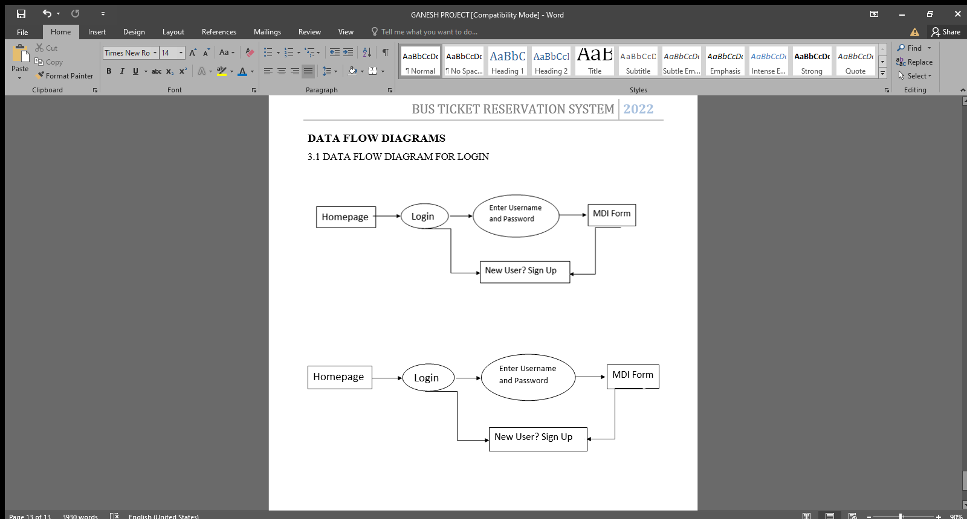

After entering to the home page of the website, user can choose the LOGIN option where they are asked to enter username & password, and if he/she is a valid user then a login page will be displayed and it will be taken to main form of home.

**3.2.2 DATA FLOW DIAGRAM FOR REGISTER FORM**

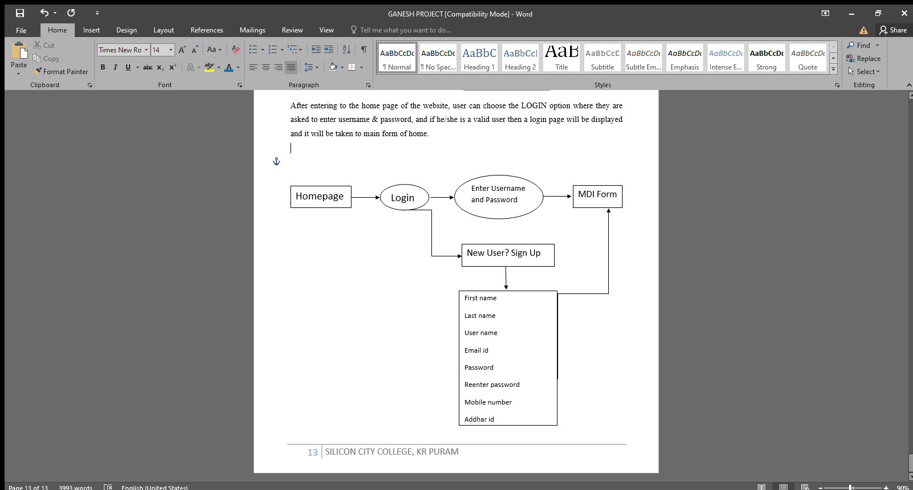

After entering to the home page of the website, user can choose the LOGIN option where they are asked to enter username and password if not user is invalid its asks for signup so we can click on NEW USER? SIGN UP so its takes to Register form and we can enter all our details which it asks and we can login and we can proceed to our booking our ticket to complete our journey.

**3.2.3 DATA FLOW DIAGRAM FOR MAIN FORM**

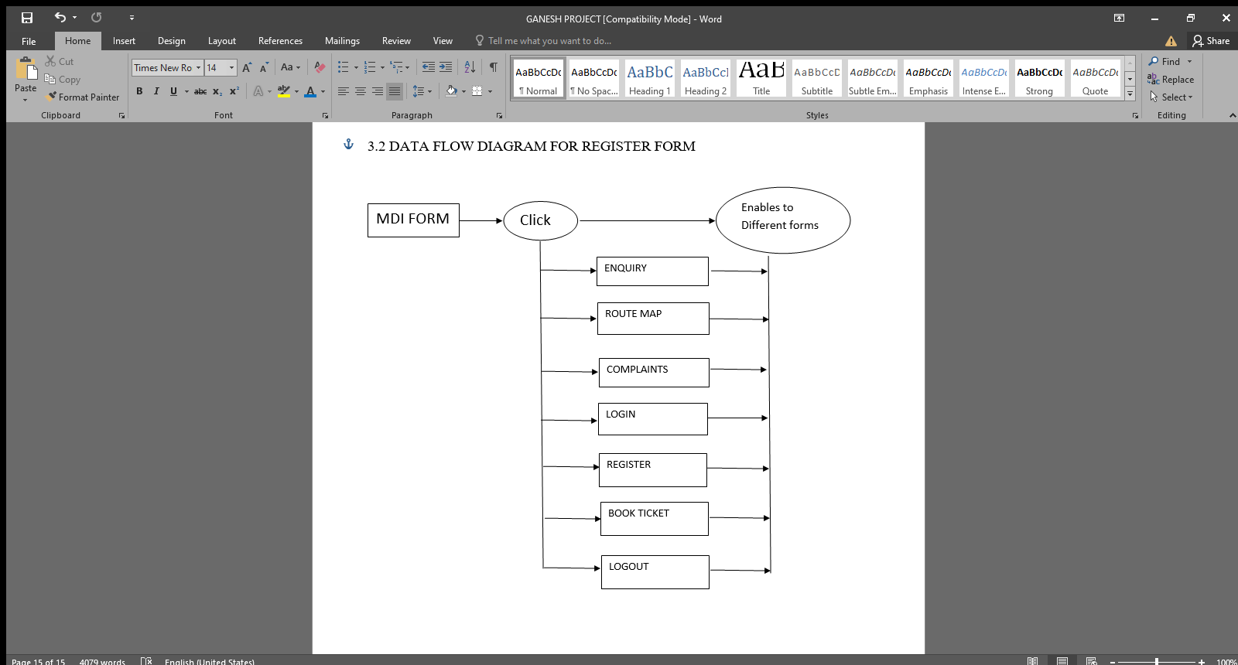

After entering the main form there we can see many main menus which are ENQUIRY – Redirects to Enquiry form and ROUTE MAP – Redirects to Route Map Form and Complaints – Redirects to Complaint Form and LOGIN – Redirects to Login Form and REGISTER – Redirects to Register Form and BOOK TICKET – Redirects to Book Ticket Form and LOGOUT – Redirects to Logout Form and we can proceed as our choice

**3.2.4 DATA FLOW DIAGRAM FOR ENQUIRY FORM**

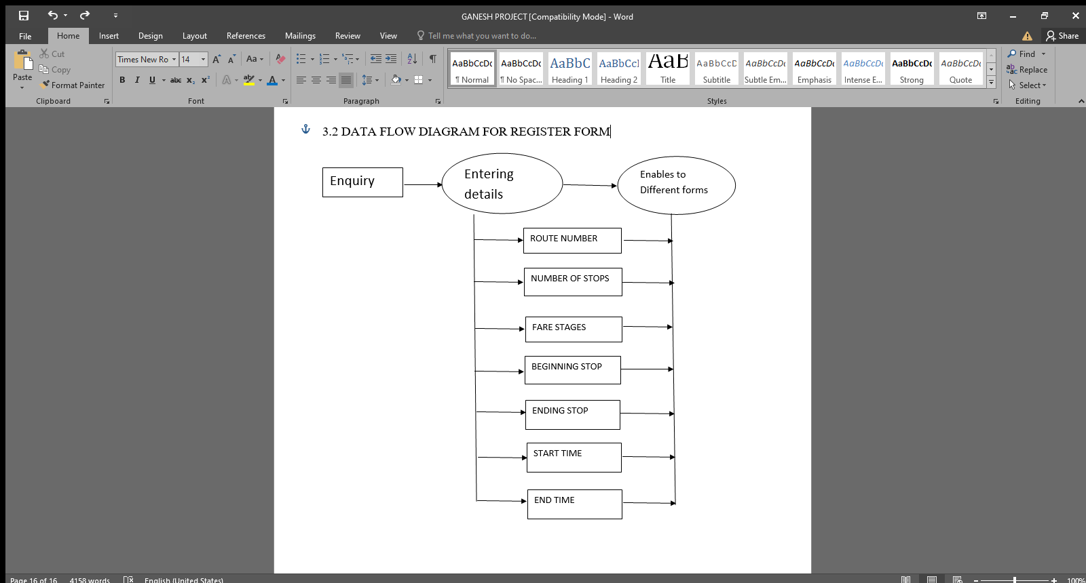

After entering the main form their we have a option called ENQUIRY and if we click on that we will be redirected to enquiry form so we need select the ROUTE NUMBER and all other boxes will be filled automatically as per stored in the database so it will be show us to see which our way to reach our destiny and if we click on PROCEED it will be redirected to again main form for BOOKING and we can proceed with that.

**3.2.5 DATA FLOW DAIGRAM FOR ROUTE MAP**

Route Map

After entering the main form if we want to see the maps were our buses travel so there is a option called ROUTE MAP if we click on that it redirects to Route form their if we select SLNO it will show us state name and state map so based on SLNO you can check the map.

**3.2.6 DATA FLOW DIAGRAM FOR COMPLAINT FORM**

Complaint

After entering the main form if a user wants to complaint for our bus company there is a separate form named COMPLAINT form so user can complaint their so just he need to select COMPLAINT NUMBER so COMPLAINT will be displayed automatically and user should DEFINE ROUTE so in which route he is facing this trouble so our company can easily find out the problem and resolve it as soon as possible.

**3.2.7 DATA FLOW DIAGRAM FOR TICKETING**

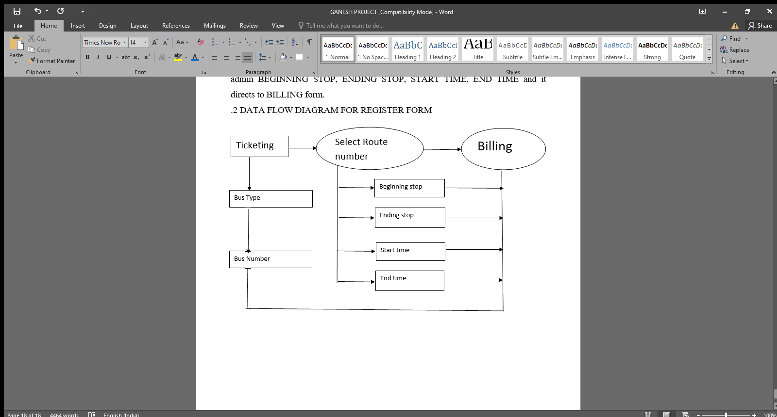

After entering the main form there is a option called BOOK TICKET and it is the main part of this website so just user need to select BUSTYPE, BUS NUMBER, SELECT ROUTE NUMBER, in this Route number as per stored in data base by admin BEGINNING STOP, ENDING STOP, START TIME, END TIME and it directs to BILLING form.

**3.2.8 DATA FLOW DIAGRAM FOR BILLING**

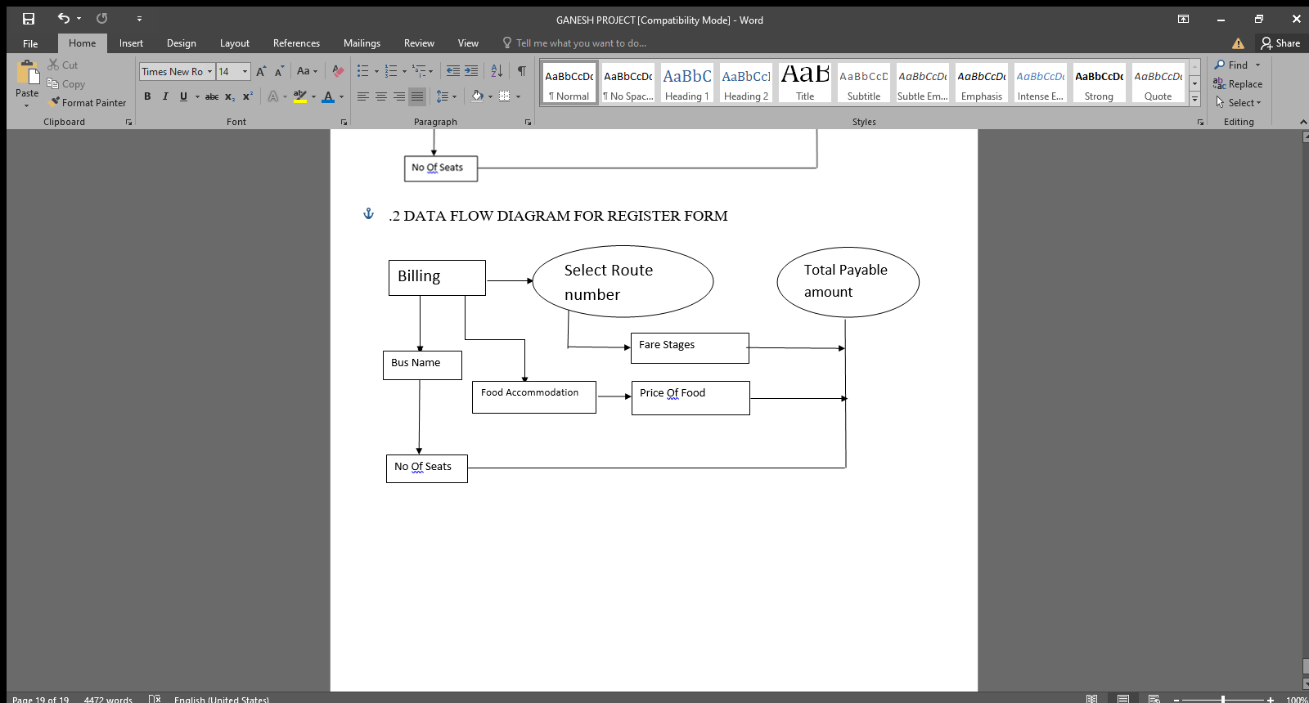

After entering the billing form from the form ticketing their we can find the SELECT ROUTE NUMBER so if we select that FARE STAGES will be displayed and we need to select BUS NAME and NO OF SEATS and FOOD ACCOMMODATION and PRICE OF FOOD will be displayed and it will be calculated and stored in data base and it will be redirected to payment form.

**3.2.9 DATA FLOW DIAGRAMS FOR BILL FORM**

PAYMENT FORMS

BILL

After entering the bill form it will ask us the payment methods such as DEBIT and CREDIT and PAYTM and PHONEPE and GPAY and CASH this many methods are to make the payment so in next forms we can complete our payment.

**3.2.10 DATA FLOW DIAGRAM FOR DEBIT AND CREDIT FORM**

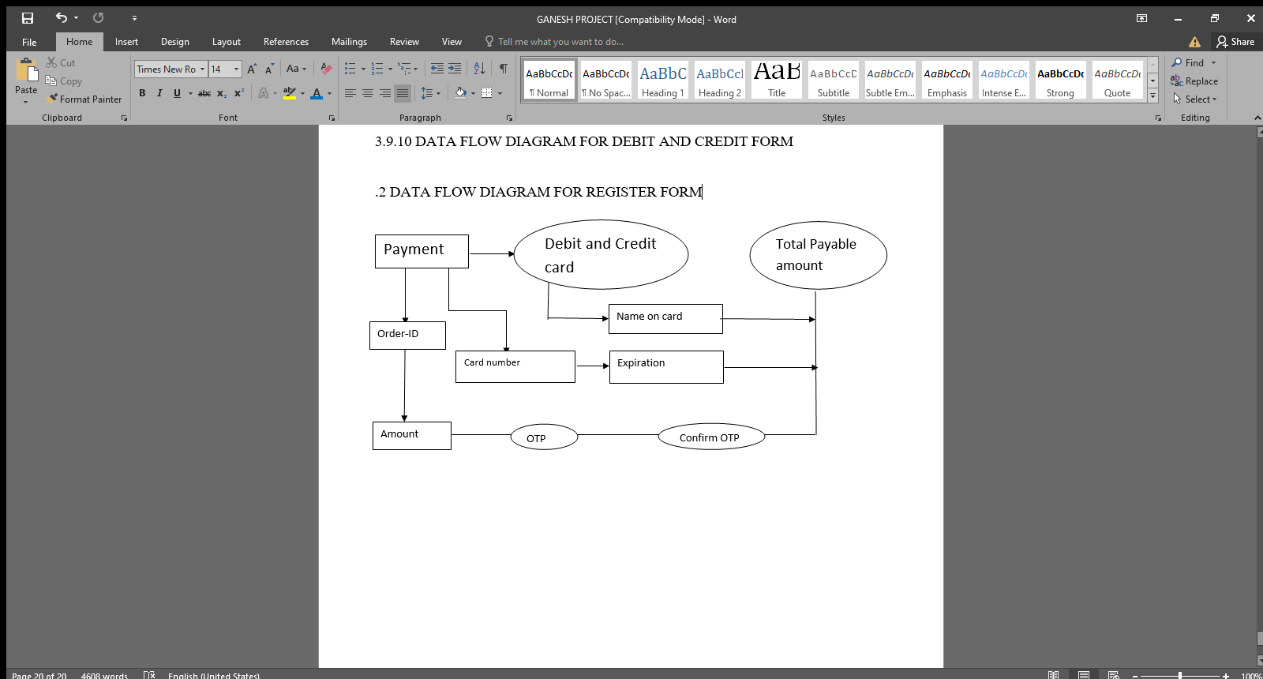

After entering the bill form it will taken to payment form so first is Debit and credit form in the user need to enter the ORDERID and amount will be fetched automatically from the database which is stored in billing form so user need to enter all the details of the card and complete the payment.

**3.2.11 DATA FLOW DIAGRAM FOR PAYTM FORM**

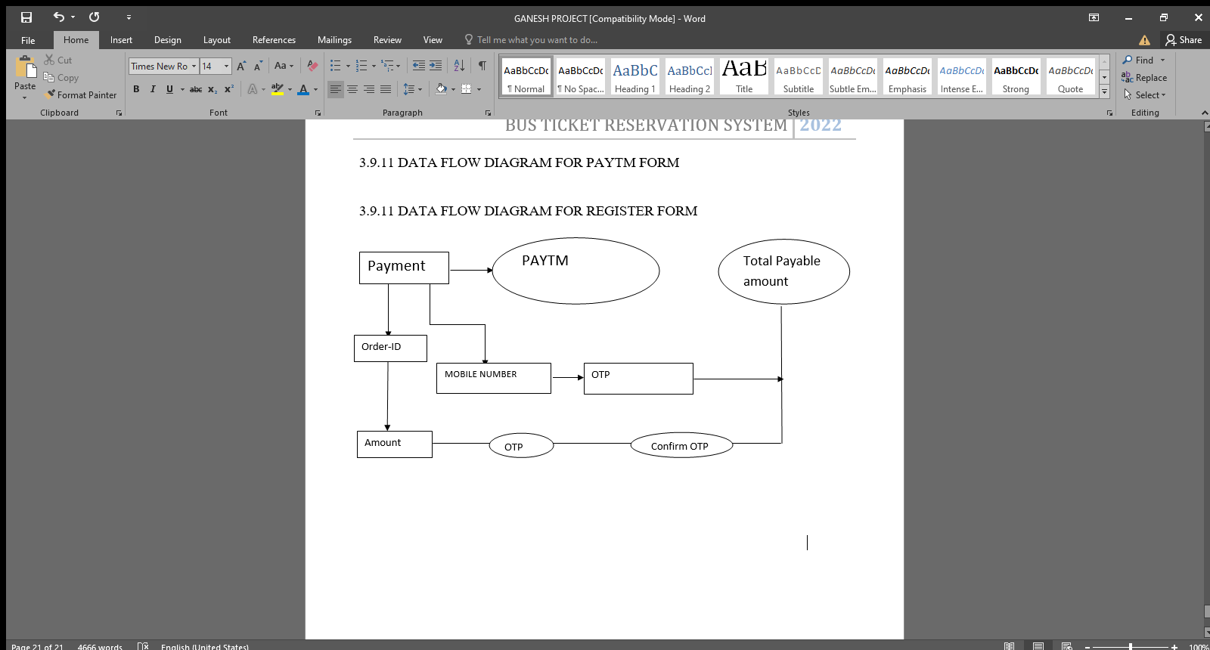

After entering the bill form it will taken to payment form so second is paytm form in the user need to enter the ORDERID and amount will be fetched automatically from the database which is stored in billing form so user need to enter all the details of the paytm account and complete the payment.

**3.2.12 DATA FLOW DIAGRAMS FOR UPI FORM**

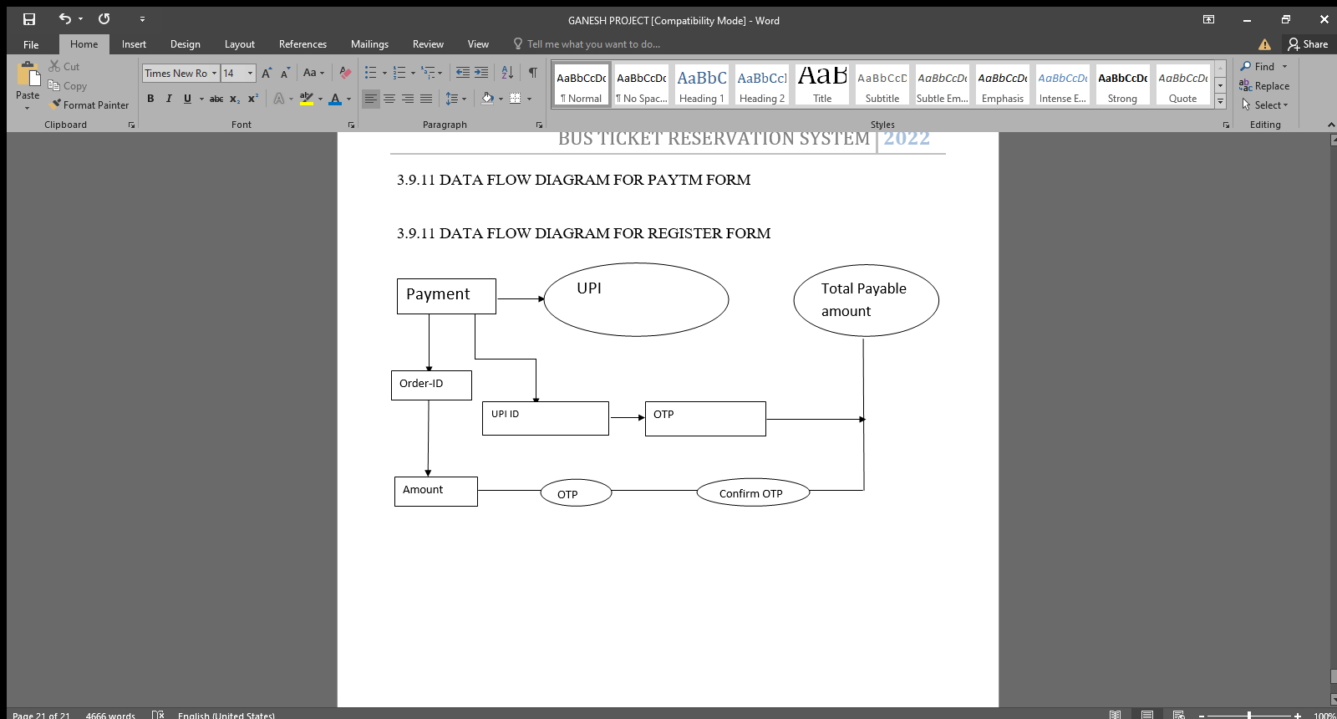

After entering the bill form it will taken to payment form so third is UPI form in the user need to enter the ORDERID and amount will be fetched automatically from the database which is stored in billing form so user need to enter all the details of the UPI APP and complete the payment.

**3.2.13 DATA FLOW DIAGRAMS FOR NET BANKING**

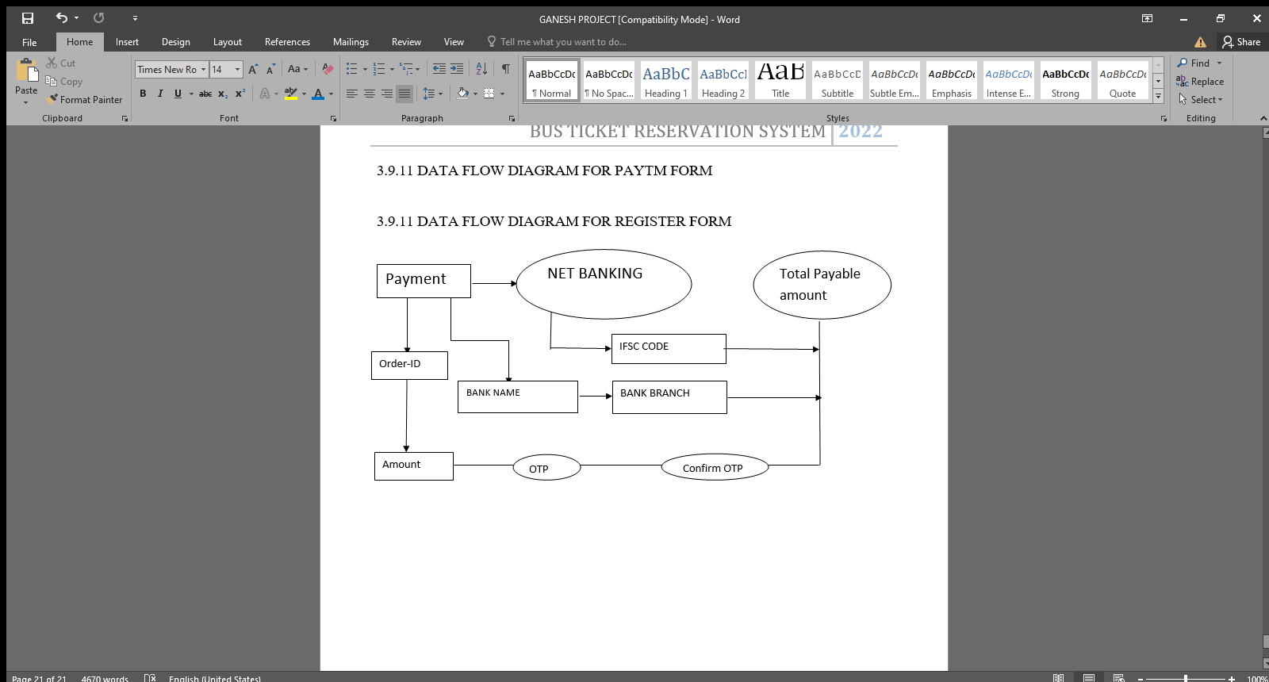

After entering the bill form it will taken to payment form so fourth is NETBANKING form in the user need to enter the ORDERID and amount will be fetched automatically from the database which is stored in billing form so user need to enter all the details of the bank account and complete the payment.

**CHAPTER – 4**

**SYSTEM IMPLEMENTATION**

**4.1.1 MODULE DISCRIPTION**

For Bus Ticket Reservation System, it is divided into the following Modules:

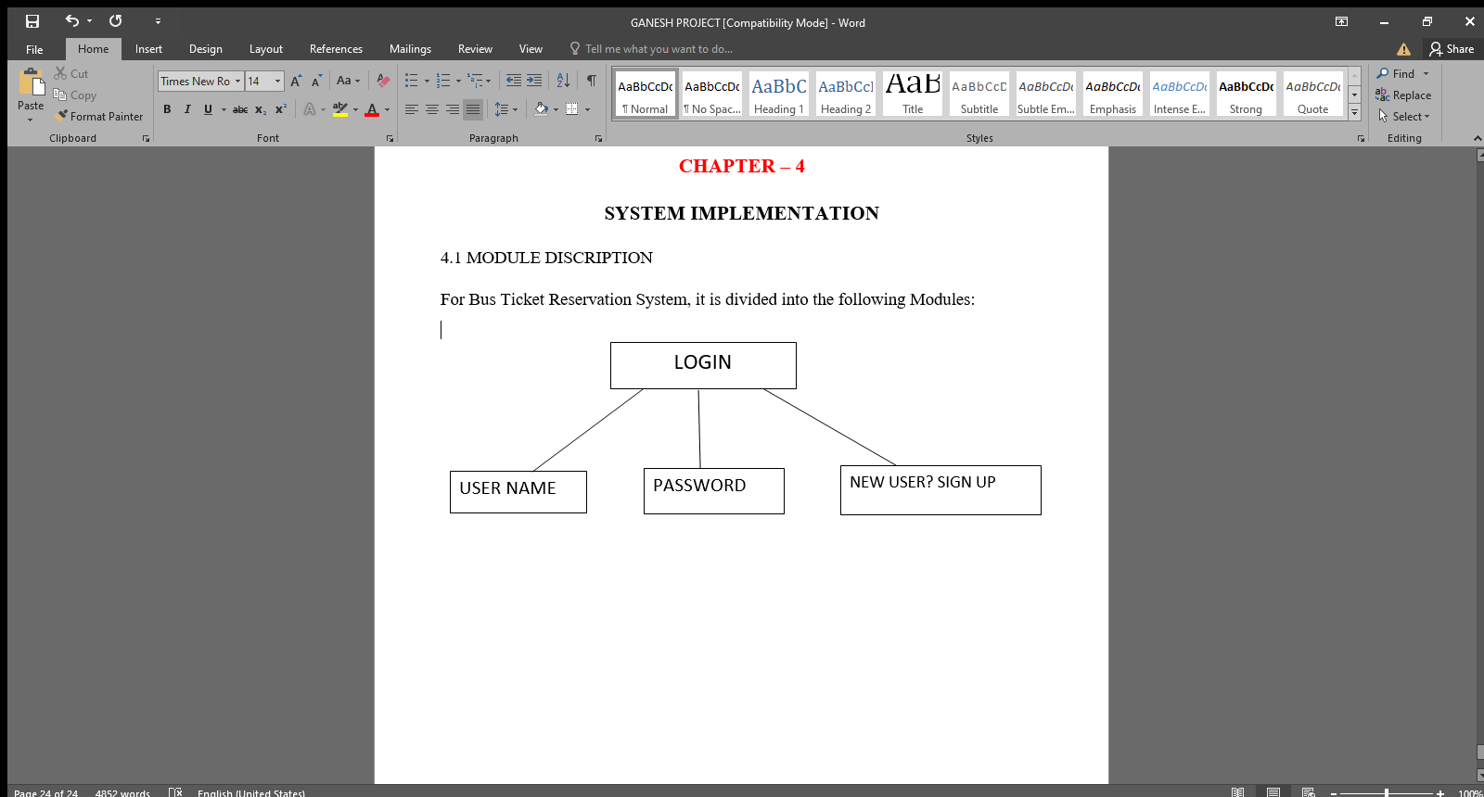

The following module contains various facilities like username, password and New User? Sign Up

**CODE FOR SPLASH FORM**

Private Sub Form_Load()

Timer1.Enabled = True

End Sub

Private Sub Timer1_Timer()

ProgressBar1.Value = ProgressBar1.Value + 5

Label1.Caption = "Loading Successful...."

Label2.Caption = ProgressBar1.Value & "%"

If (ProgressBar1.Value = ProgressBar1.Max) Then

Timer1.Enabled = False

Unload Me

Form1.Show

End If

End Sub

**CODE FOR LOGIN MODULE**

Dim username As String

Dim password As String

Dim rs As New ADODB.Recordset

Dim conn As New ADODB.Connection

Private Sub CmdLogin_Click()

If Text1.Text = "" Then

MsgBox " enter the user name", vbInformation + vbOKOnly, "login"

Text1.SetFocus

Exit Sub

End If

If Text2.Text = "" Then

MsgBox " enter the password", vbInformation + vbOKCancelonly, "login"

Text2.SetFocus

Exit Sub

End If

If Text1.Text <> "" And Text2.Text <> "" Then

If rs.State = 1 Then

rs.Close

Else

rs.Open "select * from login where username = '" & Text1 & "' and password = '" & Text2 & "'", conn, adOpenDynamic, adLockOptimistic, adCmdText

End If

If rs.EOF = True Then

MsgBox " invalid username and password.....please register", vbCritical + vbOKOnly, " login"

Text1.Text = ""

Text2.Text = ""

Text1.SetFocus

Else

MsgBox " username and password correct", vbInformation + vbOKOnly, " login"

MDIForm1.Show

End If

End If

Unload Me

End Sub

Private Sub Form_Load()

conn.Open "Provider=MSDASQL.1;Persist Security Info=False;User ID=root;Data Source=database"

End Sub

Private Sub Label1_Click()

Form2.Show

Form1.Hide

End Sub

Private Sub Label13_Click()

Form4.Show

Form1.Hide

End Sub

**4.1.2 REGISTER MODULE**

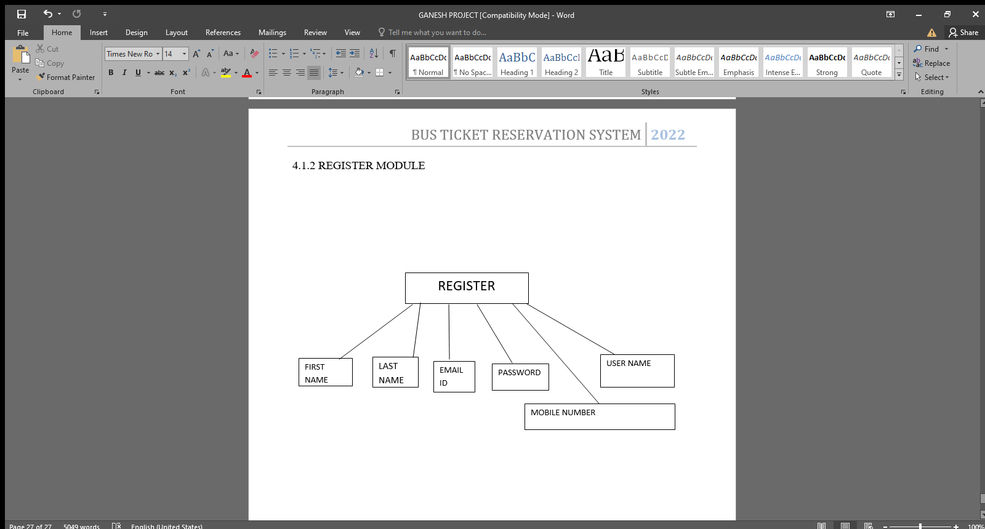

The following module contains various facilities like first name, last name email id, password, mobile number and username. Any user can register in this form.

**CODE FOR REGISTER FORM**

Dim num As Integer

Dim s1 As String

Dim s2 As String

Dim s3 As String

Dim s4 As String

Dim s5 As String

Dim s6 As String

Dim s7 As String

Dim confirm As Integer

Private Sub Command1_Click()

s1 = Text1.Text = ""

s2 = Text2.Text = ""

s3 = Text3.Text = ""

s4 = Text4.Text = ""

s5 = Text5.Text = ""

s6 = Text7.Text = ""

s7 = Text8.Text = ""

If Text1.Text = "" Or Text2.Text = "" Or Text3.Text = "" Or Text4.Text = "" Or Text5.Text = "" Or Text7.Text = "" Or Text8.Text = "" Then

MsgBox "Enter all the Details"

Exit Sub

End If

If Len(Text5.Text) < 6 Then

MsgBox "please enterv6 charcater password"

Exit Sub

End If

If Text5.Text <> Text6.Text Then

MsgBox " Password does not match"

Exit Sub

End If

Adodc1.Recordset.AddNew

Adodc1.Recordset("firstname") = Text1.Text

Adodc1.Recordset("lastname") = Text2.Text

Adodc1.Recordset("username") = Text3.Text

Adodc1.Recordset("emailid") = Text4.Text

Adodc1.Recordset("password") = Text5.Text

Adodc1.Recordset("mobilenumber") = Text7.Text

Adodc1.Recordset("addharid") = Text8.Text

Adodc1.Recordset.Update

MsgBox ("registered successfull")

Text1.Text = ""

Text2.Text = ""

Text3.Text = ""

Text4.Text = ""

Text5.Text = ""

Text7.Text = ""

Text8.Text = ""

MDIForm1.Show

Unload Me

End Sub

Private Sub Form_Load()

Adodc1.Recordset.AddNew

End Sub

Private Sub Label4_Click()

Form1.Show

Unload Me

End Sub

**4.1.3 ENQUIRY DETAILS, COMPLAINT AND BUS ROUTE MAP MODULE**

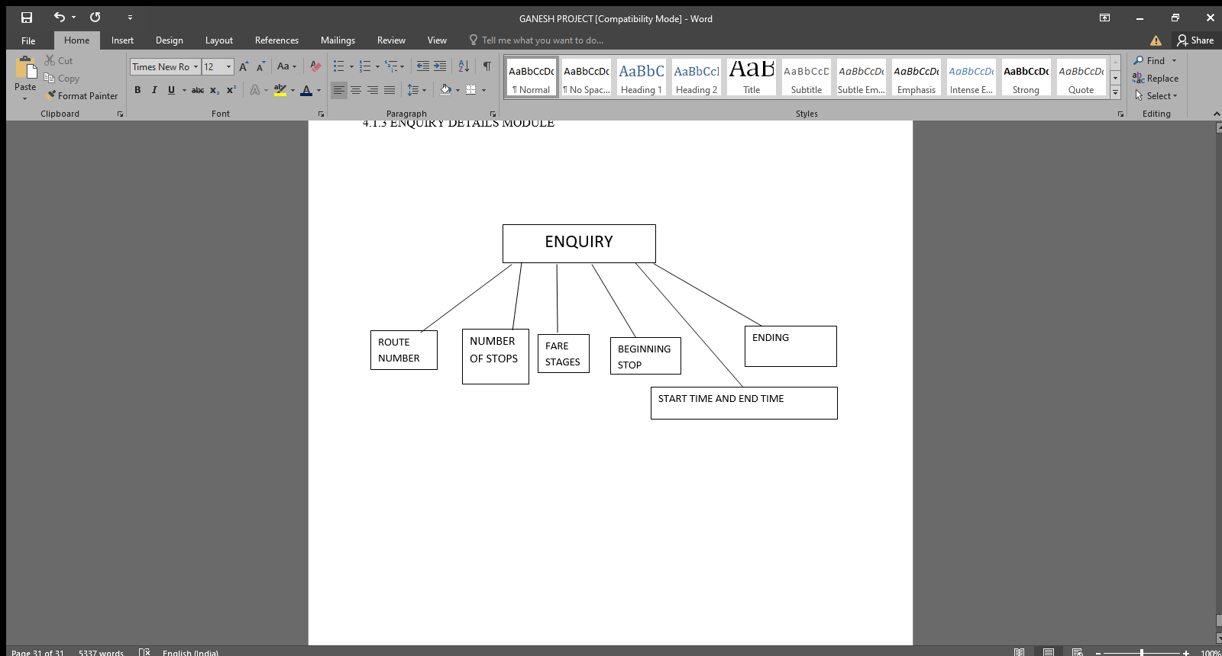

The following module contains the routenumber, number of stops, fare stages, beginning stop, ending stop, start time and end time in this module

**CODE FOR ENQUIRY DETIAL FORM**

Dim cns As ADODB.Connection

Dim rst As ADODB.Recordset

Private Sub cmdexit_Click(Index As Integer)

MDIForm1.Show

Unload Me

End Sub

Private Sub cmdnew_Click(Index As Integer)

MDIForm1.Show

Unload Me

End Sub

Private Sub Combo1_Click()

Dim rst1 As ADODB.Recordset

Set rst1 = New ADODB.Recordset

rst1.Open "select * from enquiry where Routenumber =" & Combo1.List(Combo1.ListIndex), cns

Text1.Text = rst1.Fields("Numberofstops")

Text2.Text = rst1.Fields("Farestages")

Text3.Text = rst1.Fields("Beginningstop")

Text4.Text = rst1.Fields("Endingstop")

Text5(1).Text = rst1.Fields("Starttime")

Text6(1).Text = rst1.Fields("Endtime")

End Sub

Private Sub Form_Load()

Set cns = New ADODB.Connection

Set rst = New ADODB.Recordset

cns.Open "Provider=MSDASQL.1;Persist Security Info=False;User ID=root;Data Source=database"

rst.Open "select * from enquiry", cns

Do While Not rst.EOF

Combo1.AddItem rst.Fields("Routenumber")

rst.MoveNext

Loop

End Sub

**CODE FOR COMPLAINT FORM**

Dim cns As ADODB.Connection

Dim rst As ADODB.Recordset

Private Sub Combo1_Click()

Dim rst As ADODB.Recordset

Set rst = New ADODB.Recordset

rst.Open "select Registercomplaint from enquiry where SLno =" & Combo1.List(Combo1.ListIndex), cns

Text2.Text = rst.Fields("registercomplaint")

End Sub

Private Sub Combo3_Click()

Dim rst As ADODB.Recordset

Set rst = New ADODB.Recordset

'rst.Open "select Routenumber from enquiry" & Combo3.List(Combo3.ListIndex), cns

End Sub

Private Sub Command1_Click()

MsgBox "Complaint Registered Successfully. It will be resolved within 7 working days"

MDIForm1.Show

Unload Me

End Sub

Private Sub Command2_Click()

MDIForm1.Show

Unload Me

End Sub

Private Sub Form_Load()

Set cns = New ADODB.Connection

Set rst = New ADODB.Recordset

cns.Open "Provider=MSDASQL.1;Persist Security Info=False;User ID=root;Data Source=database"

rst.Open "select * from enquiry", cns

Do While Not rst.EOF

Combo1.AddItem rst.Fields("SLno")

Combo3.AddItem rst.Fields("Routenumber")

rst.MoveNext

Loop

End Sub

**CODE FOR BUS ROUTE FORM**

Dim cns As ADODB.Connection

Dim rst As ADODB.Recordset

Private Sub Combo1_Click()

Dim rst As ADODB.Recordset

Set rst = New ADODB.Recordset

rst.Open "select State from busroute where SLNO =" & Combo1.List(Combo1.ListIndex), cns

Text1.Text = rst.Fields("State")

If Combo1.Text = "1221" Then

Image2.Picture = LoadPicture("C:\Users\gane0\OneDrive\Desktop\maps\1.jpg")

ElseIf Combo1.Text = "1889" Then

Image2.Picture = LoadPicture("C:\Users\gane0\OneDrive\Desktop\maps\2.jpg")

ElseIf Combo1.Text = "1223" Then

Image2.Picture = LoadPicture("C:\Users\gane0\OneDrive\Desktop\maps\3.jpg")

ElseIf Combo1.Text = "2312" Then

Image2.Picture = LoadPicture("C:\Users\gane0\OneDrive\Desktop\maps\4.jpg")

ElseIf Combo1.Text = "1241" Then

Image2.Picture = LoadPicture("C:\Users\gane0\OneDrive\Desktop\maps\5.gif")

ElseIf Combo1.Text = "1432" Then

Image2.Picture = LoadPicture("C:\Users\gane0\OneDrive\Desktop\maps\6.jpg")

ElseIf Combo1.Text = "1234" Then

Image2.Picture = LoadPicture("C:\Users\gane0\OneDrive\Desktop\maps\7.jpg")

ElseIf Combo1.Text = "3564" Then

Image2.Picture = LoadPicture("C:\Users\gane0\OneDrive\Desktop\maps\8.jpg")

ElseIf Combo1.Text = "2342" Then

Image2.Picture = LoadPicture("C:\Users\gane0\OneDrive\Desktop\maps\9.jpg")

ElseIf Combo1.Text = "2435" Then

Image2.Picture = LoadPicture("C:\Users\gane0\OneDrive\Desktop\maps\10.jpg")

ElseIf Combo1.Text = "1243" Then

Image2.Picture = LoadPicture("C:\Users\gane0\OneDrive\Desktop\maps\11.jpg")

ElseIf Combo1.Text = "1255" Then

Image2.Picture = LoadPicture("C:\Users\gane0\OneDrive\Desktop\maps\12.jpg")

ElseIf Combo1.Text = "1235" Then

Image2.Picture = LoadPicture("C:\Users\gane0\OneDrive\Desktop\maps\13.jpg")

ElseIf Combo1.Text = "6333" Then

Image2.Picture = LoadPicture("C:\Users\gane0\OneDrive\Desktop\maps\14.jpg")

ElseIf Combo1.Text = "4322" Then

Image2.Picture = LoadPicture("C:\Users\gane0\OneDrive\Desktop\maps\15.jpg")

ElseIf Combo1.Text = "1532" Then

Image2.Picture = LoadPicture("C:\Users\gane0\OneDrive\Desktop\maps\16.jpg")

ElseIf Combo1.Text = "6754" Then

Image2.Picture = LoadPicture("C:\Users\gane0\OneDrive\Desktop\maps\17.jpg")

ElseIf Combo1.Text = "8954" Then

Image2.Picture = LoadPicture("C:\Users\gane0\OneDrive\Desktop\maps\18.jpg")

ElseIf Combo1.Text = "9834" Then

Image2.Picture = LoadPicture("C:\Users\gane0\OneDrive\Desktop\maps\19.jpg")

ElseIf Combo1.Text = "9082" Then

Image2.Picture = LoadPicture("C:\Users\gane0\OneDrive\Desktop\maps\20.jpg")

ElseIf Combo1.Text = "8922" Then

Image2.Picture = LoadPicture("C:\Users\gane0\OneDrive\Desktop\maps\21.jpg")

ElseIf Combo1.Text = "9023" Then

Image2.Picture = LoadPicture("C:\Users\gane0\OneDrive\Desktop\maps\22.jpg")

ElseIf Combo1.Text = "0923" Then

Image2.Picture = LoadPicture("C:\Users\gane0\OneDrive\Desktop\maps\23.jpg")

ElseIf Combo1.Text = "8972" Then

Image2.Picture = LoadPicture("C:\Users\gane0\OneDrive\Desktop\maps\24.jpg")

ElseIf Combo1.Text = "2923" Then

Image2.Picture = LoadPicture("C:\Users\gane0\OneDrive\Desktop\maps\25.jpg")

ElseIf Combo1.Text = "2992" Then

Image2.Picture = LoadPicture("C:\Users\gane0\OneDrive\Desktop\maps\26.jpg")

ElseIf Combo1.Text = "9290" Then

Image2.Picture = LoadPicture("C:\Users\gane0\OneDrive\Desktop\maps\27.jpg")

ElseIf Combo1.Text = "8875" Then

Image2.Picture = LoadPicture("C:\Users\gane0\OneDrive\Desktop\maps\28.jpg")

End If

End Sub

Private Sub Command1_Click()

MDIForm1.Show

Unload Me

End Sub

Private Sub Form_Load()

Set cns = New ADODB.Connection

Set rst = New ADODB.Recordset

cns.Open "Provider=MSDASQL.1;Persist Security Info=False;User ID=root;Data Source=database"

rst.Open "select * from busroute", cns

Do While Not rst.EOF

Combo1.AddItem rst.Fields("SLNO")

rst.MoveNext

Loop

End Sub

**4.1.4 MDI FORM MODULE**

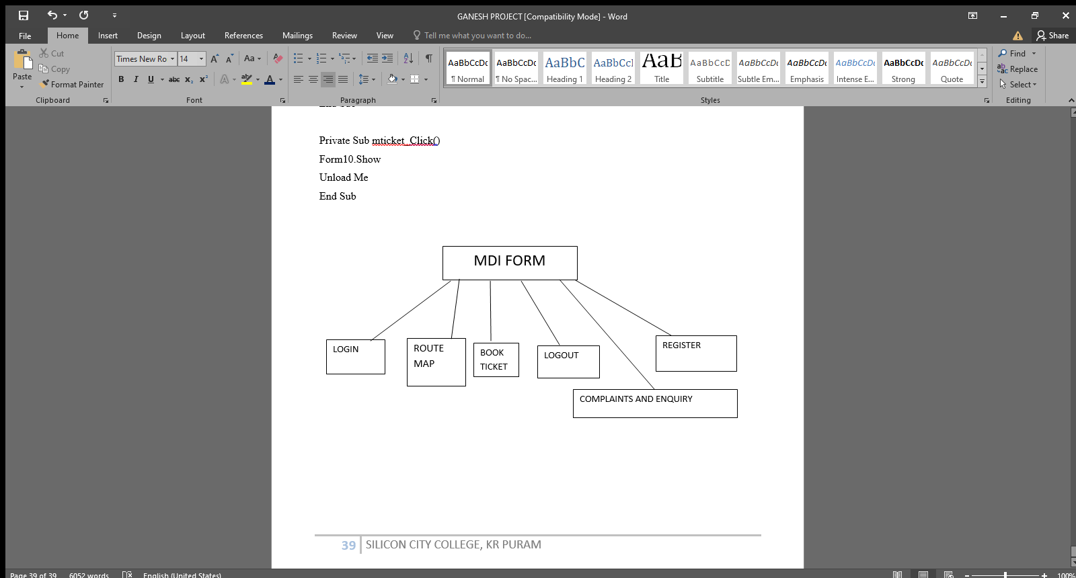

The following contains the LOGIN, ROUTEMAP BOOK TICKET, LOGOUT, COMPLAINTS AND ENQUIRY, REGISTER so this is the main form

**CODE FOR MAIN FORM**

Private Sub Label1_Click()

Form1.Show

Unload Me

End Sub

Private Sub Label10_Click()

Form5.Show

Unload Me

End Sub

Private Sub Label12_Click()

Form7.Show

Unload Me

End Sub

Private Sub Label13_Click()

Form3.Show

Unload Me

End Sub

Private Sub Label15_Click()

Form9.Show

Unload Me

End Sub

Private Sub Label5_Click()

Form2.Show

Unload Me

End Sub

Private Sub Label7_Click()

Form10.Show

Unload Me

End Sub

Private Sub mcomplaint_Click(Index As Integer)

Form3.Show

Unload Me

End Sub

Private Sub MEnd_Click()

Form5.Show

Unload Me

End Sub

Private Sub mlogin_Click(Index As Integer)

Form1.Show

Unload Me

End Sub

Private Sub mlogout_Click()

Form1.Show

Unload Me

End Sub

Private Sub mnbooking_Click()

Form10.Show

Unload Me

End Sub

Private Sub mncomplaint_Click()

Form3.Show

Unload Me

End Sub

Private Sub mnlogout_Click()

Form1.Show

Unload Me

End Sub

Private Sub mregister_Click()

Form2.Show

Unload Me

End Sub

Private Sub mroutemap_Click()

Form9.Show

Unload Me

End Sub

Private Sub mticket_Click()

Form10.Show

Unload Me

End Sub

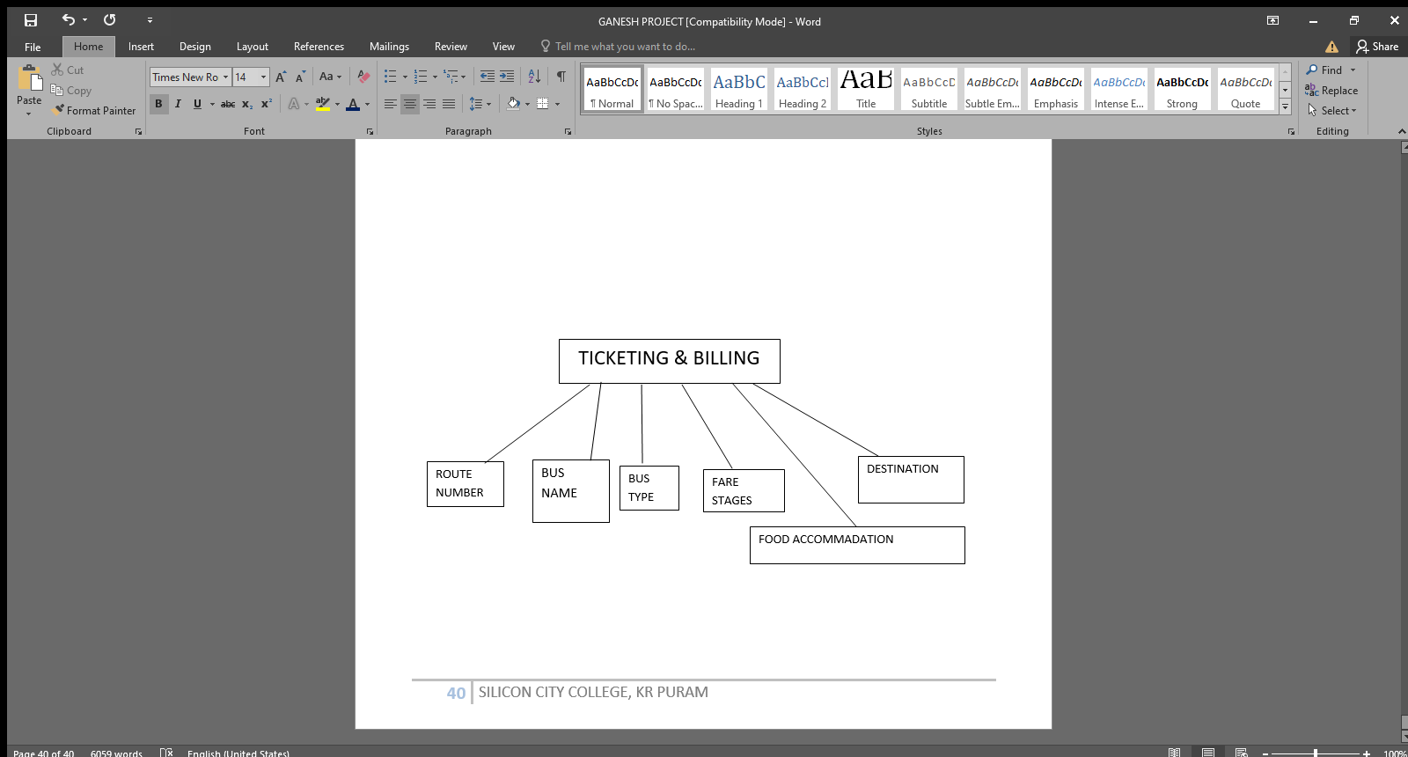**4.1.5 TICKETING AND BILLING FORM**

The following module contains of BUS MAP, BUS ROUTE, BUS TYPE, FARE STAGES, ROUTE NUMBER, DATE, BEGINNING STOP, ENDING STOP, START FROM, STOP POINT, NO OF SEATS, FOOD ACCOMMODATION, PRICE OF FOOD, TOTAL PAYABLE AMOUNT

**CODE FOR TICKETING FORM**

Dim cns As ADODB.Connection

Dim rst As ADODB.Recordset

Dim cns1 As ADODB.Connection

Dim rst1 As ADODB.Recordset

Dim num As Integer

Dim s1 As String

Dim s2 As String

Dim confirm As Integer

Private Sub Cmdclear_Click(Index As Integer)

Combo1.Clear

Combo2.Clear

Combo3.Clear

Text1.Text = ""

Text2.Text = ""

Text3.Text = ""

Text4.Text = ""

End Sub

Private Sub cmdexit_Click(Index As Integer)

MDIForm1.Show

Unload Me

End Sub

Private Sub Combo1_Click()

Dim rst As ADODB.Recordset

Set rst = New ADODB.Recordset

End Sub

Private Sub Combo2_Click()

Dim rst1 As ADODB.Recordset

Set rst1 = New ADODB.Recordset

End Sub

Private Sub Combo3_Click()

Dim rst1 As ADODB.Recordset

Set rst1 = New ADODB.Recordset

rst1.Open "select * from enquiry where Routenumber =" & Combo3.List(Combo3.ListIndex), cns1

Text1.Text = rst1.Fields("Beginningstop")

Text3.Text = rst1.Fields("Endingstop")

End Sub

Private Sub Command1_Click()

s1 = Combo1.Text = ""

s2 = Combo2.Text = ""

s3 = Combo3.Text = ""

s4 = Text1.Text = ""

s5 = Text2.Text = ""

s6 = Text3.Text = ""

s7 = Text4.Text = ""

If Combo1.Text = "" Or Combo2.Text = "" Or Combo3.Text = "" Or Text1.Text = "" Or Text2.Text = "" Or Text3.Text = "" Or Text4.Text = "" Then

MsgBox "please enter all the details"

Combo1.SetFocus

Combo2.SetFocus

Combo3.SetFocus

Text1.SetFocus

Text2.SetFocus

Text3.SetFocus

Text4.SetFocus

Exit Sub

End If

Form4.Show

Unload Me

End Sub

Private Sub Form_Load()

Set cns = New ADODB.Connection

Set rst = New ADODB.Recordset

cns.Open "Provider=MSDASQL.1;Persist Security Info=False;User ID=root;Data Source=database"

rst.Open "select * from ticketing", cns

Do While Not rst.EOF

Combo1.AddItem rst.Fields("Bustype")

rst.MoveNext

Loop

Set cns1 = New ADODB.Connection

Set rst1 = New ADODB.Recordset

cns1.Open "Provider=MSDASQL.1;Persist Security Info=False;User ID=root;Data Source=database"

rst1.Open "select * from enquiry", cns1

Do While Not rst1.EOF

Combo2.AddItem rst1.Fields("Busnumber")

Combo3.AddItem rst1.Fields("Routenumber")

rst1.MoveNext

Loop

End Sub

**CODE FOR BILLING FORM**

Dim cns As ADODB.Connection

Dim rst As ADODB.Recordset

Dim cns1 As ADODB.Connection

Dim rst1 As ADODB.Recordset

Dim num As Integer

Dim s1 As String

Dim confirm As Integer

Private Sub Combo1_Click()

Dim rst1 As ADODB.Recordset

Set rst1 = New ADODB.Recordset

rst1.Open "select Farestages from enquiry where Routenumber =" & Combo1.List(Combo1.ListIndex), cns1

Text2.Text = rst1.Fields("Farestages")

End Sub

Private Sub Combo2_Click()

Dim rst As ADODB.Recordset

Set rst = New ADODB.Recordset

End Sub

Private Sub Combo3_Click()

Dim rst As ADODB.Recordset

Set rst = New ADODB.Recordset

End Sub

Private Sub Combo4_Click()

Dim rst As ADODB.Recordset

Set rst = New ADODB.Recordset

If Combo4.Text = "Biryani" Then

Text3.Text = 100

ElseIf Combo4.Text = "Rice" Then

Text3.Text = 100

ElseIf Combo4.Text = "LemonRice" Then

Text3.Text = 50

ElseIf Combo4.Text = "VegPalav" Then

Text3.Text = 70

ElseIf Combo4.Text = "Chapathi6Pcs" Then

Text3.Text = 80

ElseIf Combo4.Text = "Meals" Then

Text3.Text = 150

ElseIf Combo4.Text = "MiniMeals" Then

Text3.Text = 80

ElseIf Combo4.Text = "Kushka" Then

Text3.Text = 70

End If

End Sub

Private Sub Command1_Click()

s1 = Text1.Text = ""

s2 = Text2.Text = ""

s3 = Text3.Text = ""

s4 = Combo1.Text = ""

s5 = Combo2.Text = ""

s6 = Combo3.Text = ""

s7 = Combo4.Text = ""

If Text1.Text = "" Or Text2.Text = "" Or Text3.Text = "" Or Combo1.Text = "" Or Combo2.Text = "" Or Combo3.Text = "" Or Combo4.Text = "" Then

MsgBox "please enter all the details"

Text1.SetFocus

Text2.SetFocus

Text3.SetFocus

Combo3.SetFocus

Combo1.SetFocus

Combo2.SetFocus

Combo4.SetFocus

Exit Sub

End If

If Combo1.Text = "18897" Then

MsgBox "Order Id:- AAY1123221"

ElseIf Combo1.Text = "16754" Then

MsgBox "Order Id:- AAY1123222"

ElseIf Combo1.Text = "13324" Then

MsgBox "Order Id:- AAY1123223"

ElseIf Combo1.Text = "44567" Then

MsgBox "Order Id:- AAY1123224"

ElseIf Combo1.Text = "84384" Then

MsgBox "Order Id:- AAY1123225"

ElseIf Combo1.Text = "66654" Then

MsgBox "Order Id:- AAY1123226"

ElseIf Combo1.Text = "76556" Then

MsgBox "Order Id:- AAY1123227"

ElseIf Combo1.Text = "18897" Then

MsgBox "Order Id:- AAY1123228"

ElseIf Combo1.Text = "66758" Then

MsgBox "Order Id:- AAY1123229"

ElseIf Combo1.Text = "77778" Then

MsgBox "Order Id:- AAY1123230"

ElseIf Combo1.Text = "55636" Then

MsgBox "Order Id:- AAY1123231"

ElseIf Combo1.Text = "7768" Then

MsgBox "Order Id:- AAY1123232"

ElseIf Combo1.Text = "88756" Then

MsgBox "Order Id:- AAY1123233"

ElseIf Combo1.Text = "77785" Then

MsgBox "Order Id:- AAY1123234"

ElseIf Combo1.Text = "11234" Then

MsgBox "Order Id:- AAY1123235"

ElseIf Combo1.Text = "11564" Then

MsgBox "Order Id:- AAY1123236"

ElseIf Combo1.Text = "76676" Then

MsgBox "Order Id:- AAY1123237"

End If

s1 = Text1.Text = ""

If Text1.Text = "" Then

Exit Sub

End If

Adodc3.Recordset.AddNew

Adodc3.Recordset("amount") = Text1.Text

Adodc3.Recordset.Update

Text1.Text = ""

Form11.Show

Unload Me

End Sub

Private Sub Command2_Click()

Form10.Show

Unload Me

End Sub

Private Sub Command3_Click()

Sum = (Val(Text2.Text) * Val(Combo3.Text)) + (Val(Combo3.Text) * Val(Text3.Text))

Text1.Text = Sum

End Sub

Private Sub Form_Load()

Set cns = New ADODB.Connection

Set rst = New ADODB.Recordset

cns.Open "Provider=MSDASQL.1;Persist Security Info=False;User ID=root;Data Source=database"

rst.Open "select * from billing", cns

Do While Not rst.EOF

Combo2.AddItem rst.Fields("Busname")

Combo3.AddItem rst.Fields("Noofseats")

Combo4.AddItem rst.Fields("Foodaccomidation")

rst.MoveNext

Loop

Set cns1 = New ADODB.Connection

Set rst1 = New ADODB.Recordset

cns1.Open "Provider=MSDASQL.1;Persist Security Info=False;User ID=root;Data Source=database"

rst1.Open "select * from enquiry", cns1

Do While Not rst1.EOF

Combo1.AddItem rst1.Fields("Routenumber")

rst1.MoveNext

Loop

Adodc3.Recordset.AddNew

End Sub

**4.1.6 BILL & PAYMENT MODULE**

BILL & PAYMENT

UPI

DAC

PAYTM

G PAY

PHONE PAY

NET BANKING

The following contains the bill and payment form such as DEBIT AND CREDIT, PAYTM, PHONEPAY, GPAY, UPI, NETBANKING, CASH so this are the methods of payment

**CODE FOR BILL & PAYMENT**

Private Sub Command1_Click()

If Option1.Value = True Then

Form12.Show

Unload Me

ElseIf Option2.Value = True Then

Form13.Show

Unload Me

ElseIf Option3.Value = True Then

Form14.Show

Unload Me

ElseIf Option4.Value = True Then

Form15.Show

Unload Me

ElseIf Option5.Value = True Then

MsgBox “Thanks for using our website your ticket has been confirmed”

Form5.Show

Unload Me

End If

End Sub

**CODE FOR DEBIT AND CREDIT PAYMENT**

Dim cns As ADODB.Connection

Dim rst As ADODB.Recordset

Dim num As Integer

Dim s1 As String

Dim confrim As Integer

Private Sub Command1_Click()

Text1.Text = ""

Text2.Text = ""

Text3.Text = ""

Text4.Text = ""

Text5.Text = ""

Text6.Text = ""

Text7.Text = ""

Text8.Text = ""

Text9.Text = ""

End Sub

Private Sub Command2_Click()

Dim rst As ADODB.Recordset

Set rst = New ADODB.Recordset

If Text8 = "" Then

MsgBox "please enter the order id"

Text8.SetFocus

Exit Sub

End If

rst.Open "select * from amount1 where amount", cns

Text9.Text = rst.Fields("amount")

End Sub

Private Sub Command3_Click()

Form4.Show

Unload Me

End Sub

Private Sub Command4_Click()

s1 = Text1.Text = ""

s2 = Text2.Text = ""

s3 = Text3.Text = ""

s4 = Text4.Text = ""

s5 = Text5.Text = ""

s6 = Text6.Text = ""

s7 = Text8.Text = ""

s8 = Text9.Text = ""

If Text6.Text = "" Or Text5.Text = "" Or Text1.Text = "" Or Text2.Text = "" Or Text3.Text = "" Or Text4.Text = "" Or Text8.Text = "" Or Text9.Text = "" Then

MsgBox "please enter all the details"

Text5.SetFocus

Text6.SetFocus

Text1.SetFocus

Text2.SetFocus

Text3.SetFocus

Text4.SetFocus

Text8.SetFocus

Text9.SetFocus

Exit Sub

End If

MsgBox "OTP Sent Succesfully"

End Sub

Private Sub Command5_Click()

Dim rst As ADODB.Recordset

Set rst = New ADODB.Recordset

s1 = Text1.Text = ""

s2 = Text2.Text = ""

s3 = Text3.Text = ""

s4 = Text4.Text = ""

s5 = Text5.Text = ""

s6 = Text6.Text = ""

s7 = Text7.Text = ""

s8 = Text8.Text = ""

s9 = Text9.Text = ""

If Text6.Text = "" Or Text5.Text = "" Or Text7.Text = "" Or Text1.Text = "" Or Text2.Text = "" Or Text3.Text = "" Or Text4.Text = "" Or Text8.Text = "" Or Text9.Text = "" Then

MsgBox "please enter all the details"

Text5.SetFocus

Text6.SetFocus

Text7.SetFocus

Text1.SetFocus

Text2.SetFocus

Text3.SetFocus

Text4.SetFocus

Text8.SetFocus

Text9.SetFocus

Exit Sub

End If

MsgBox "Thanks for Using our Website your ticket has been confirmed"

Form5.Show

Unload Me

rst.Open "delete from amount1 where amount", cns

End Sub

Private Sub Command6_Click()

s1 = Text7.Text = ""

If Text7.Text = "" Then

MsgBox "please enter otp"

Text7.SetFocus

Exit Sub

End If

MsgBox "OTP Verified"

End Sub

Private Sub Form_Load()

Set cns = New ADODB.Connection

Set rst = New ADODB.Recordset

cns.Open "Provider=MSDASQL.1;Persist Security Info=False;User ID=root;Data Source=database"

rst.Open "select * from amount1", cns

Do While Not rst.EOF

rst.MoveNext

Loop

End Sub

**CODE FOR PAYTM PAYMENT**

Dim cns As ADODB.Connection

Dim rst As ADODB.Recordset

Dim num As Integer

Dim s1 As String

Dim confrim As Integer

Private Sub Command1_Click()

Text1.Text = ""

Text2.Text = ""

Text3.Text = ""

Text4.Text = ""

End Sub

Private Sub Command2_Click()

Dim rst As ADODB.Recordset

Set rst = New ADODB.Recordset

If Text1 = "" Then

MsgBox "please enter order id"

Text1.SetFocus

Exit Sub

End If

rst.Open "select * from amount1 where amount", cns

Text2.Text = rst.Fields("amount")

End Sub

Private Sub Command3_Click()

Form4.Show

Unload Me

End Sub

Private Sub Command4_Click()

s1 = Text3.Text = ""

If Text3.Text = "" Then

MsgBox "please enter mobile number"

Text3.SetFocus

Exit Sub

End If

If Len(Text3.Text) = 10 Then

MsgBox "OTP sent Sucessfully"

Else

MsgBox "Enter Valid Mobile Number"

End If

End Sub

Private Sub Command5_Click()

Dim rst As ADODB.Recordset

Set rst = New ADODB.Recordset

s1 = Text1.Text = ""

s2 = Text2.Text = ""

s3 = Text3.Text = ""

s4 = Text4.Text = ""

If Text1.Text = "" Or Text2.Text = "" Or Text3.Text = "" Or Text4.Text = "" Then

MsgBox "please enter all the details"

Text1.SetFocus

Text2.SetFocus

Text3.SetFocus

Text4.SetFocus

Exit Sub

End If

MsgBox "Thanks for Using our Website your ticket has been confirmed"

Form5.Show

Unload Me

rst.Open "delete from amount1 where amount", cns

End Sub

Private Sub Command6_Click()

s1 = Text4.Text = ""

If Text4.Text = "" Then

MsgBox "please enter otp"

Text4.SetFocus

Exit Sub

End If

MsgBox "OTP Verified"

End Sub

Private Sub Form_Load()

Set cns = New ADODB.Connection

Set rst = New ADODB.Recordset

cns.Open "Provider=MSDASQL.1;Persist Security Info=False;User ID=root;Data Source=database"

rst.Open "select * from amount1", cns

Do While Not rst.EOF

rst.MoveNext

Loop

End Sub

CODE FOR UPI PAYMENT

Dim cns As ADODB.Connection

Dim rst As ADODB.Recordset

Dim num As Integer

Dim s1 As Integer

Dim confrim As Integer

Private Sub Command1_Click()

Combo1.Clear

Text1.Text = ""

Text2.Text = ""

Text3.Text = ""

Text4.Text = ""

Text5.Text = ""

End Sub

Private Sub Command2_Click()

Dim rst As ADODB.Recordset

Set rst = New ADODB.Recordset

If Text5 = "" Then

MsgBox "please enter order id"

Text5.SetFocus

Exit Sub

End If

rst.Open "select * from amount1 where amount", cns

Text2.Text = rst.Fields("amount")

End Sub

Private Sub Command3_Click()

Form4.Show

Unload Me

End Sub

Private Sub Command4_Click()

s1 = Text1.Text = ""

s2 = Text2.Text = ""

s3 = Text5.Text = ""

s4 = Text3.Text = ""

s5 = Combo1.Text = ""

If Text1.Text = "" Or Text2.Text = "" Or Text3.Text = "" Or Text4.Text = "" Or Text5.Text = "" Or Combo1.Text = "" Then

MsgBox "please enter mobile number"

Text1.SetFocus

Text2.SetFocus

Text5.SetFocus

Text3.SetFocus

Combo1.SetFocus

Exit Sub

End If

If Len(Text3.Text) = 10 Then

MsgBox "OTP sent Sucessfully"

Else

MsgBox "Enter Valid Mobile Number"

End If

End Sub

Private Sub Command5_Click()

Dim rst As ADODB.Recordset

Set rst = New ADODB.Recordset

s1 = Text1.Text = ""

s2 = Text2.Text = ""

s3 = Text4.Text = ""

s4 = Text5.Text = ""

s5 = Text3.Text = ""

s6 = Combo1.Text = ""

If Text1.Text = "" Or Text2.Text = "" Or Text3.Text = "" Or Text4.Text = "" Or Text5.Text = "" Or Combo1.Text = "" Then

MsgBox "please enter all the details"

Text1.SetFocus

Text2.SetFocus

Text4.SetFocus

Text5.SetFocus

Text3.SetFocus

Combo1.SetFocus

Exit Sub

End If

MsgBox "Thanks for Using our Website your ticket has been confirmed"

Form5.Show

Unload Me

rst.Open "delete from amount1 where amount", cns

End Sub

Private Sub Command6_Click()

s1 = Text4.Text = ""

If Text4.Text = "" Then

MsgBox "please enter otp"

Text4.SetFocus

Exit Sub

End If

MsgBox "OTP Verified"

End Sub

Private Sub Form_Load()

Set cns = New ADODB.Connection

Set rst = New ADODB.Recordset

cns.Open "Provider=MSDASQL.1;Persist Security Info=False;User ID=root;Data Source=database"

rst.Open "select * from amount1", cns

Do While Not rst.EOF

rst.MoveNext

Loop

Combo1.AddItem "Googlepay"

Combo1.AddItem "Phonepay"

Combo1.AddItem "AmazonPay"

Combo1.AddItem "Whatsapp"

Combo1.AddItem "paytm"

Combo1.AddItem "BhimUPI"

End Sub

**CODE FOR NET BANKING PAYMENT**

Dim cns As ADODB.Connection

Dim rst As ADODB.Recordset

Dim cns1 As ADODB.Connection

Dim rst1 As ADODB.Recordset

Dim num As Integer

Dim s1 As String

Dim confirm As Integer

Private Sub Combo1_Click()

Dim rst As ADODB.Recordset

Set rst = New ADODB.Recordset

End Sub

Private Sub Combo2_Click()

Dim rst As ADODB.Recordset

Set rst = New ADODB.Recordset

If Combo2.Text = "Marthalli" Then

Text1.Text = "LKJKA786213"

ElseIf Combo2.Text = "Krpuram" Then

Text1.Text = "HASL21238"

ElseIf Combo2.Text = "TCPALYA" Then

Text1.Text = "HJASH89712"

ElseIf Combo2.Text = "Seggahalli" Then

Text1.Text = "BABRB8123"

ElseIf Combo2.Text = "Kadugudi" Then

Text1.Text = "CORYU3212"

ElseIf Combo2.Text = "Chintamani" Then

Text1.Text = "SBIIN3211"

ElseIf Combo2.Text = "Bhatalapalli" Then

Text1.Text = "KARN789123"

ElseIf Combo2.Text = "Whitefeild" Then

Text1.Text = "BARBO897132"

ElseIf Combo2.Text = "Varthur" Then

Text1.Text = "SBBIN878321"

ElseIf Combo2.Text = "Gunjur" Then

Text1.Text = "KOTA89Y312"

ElseIf Combo2.Text = "Kolar" Then

Text1.Text = "987073KJASD"

ElseIf Combo2.Text = "Bangerpet" Then

Text1.Text = "OJPA07321"

ElseIf Combo2.Text = "Mulbagal" Then

Text1.Text = "GANE2384E"

ElseIf Combo2.Text = "Mysore" Then

Text1.Text = "KKIIE87211"

ElseIf Combo2.Text = "Mangalore" Then

Text1.Text = "HHYYAI8132"

ElseIf Combo2.Text = "Shivvamoga" Then

Text1.Text = "GGWYY3211"

ElseIf Combo2.Text = "Dharwad" Then

Text1.Text = "KRPU88721"

End If

End Sub

Private Sub Command1_Click()

Combo1.Clear

Combo2.Clear

Text1.Text = ""

Text2.Text = ""

Text4.Text = ""

Text5.Text = ""

End Sub

Private Sub Command2_Click()

Dim rst1 As ADODB.Recordset

Set rst1 = New ADODB.Recordset

If Text5 = "" Then

MsgBox "please enter all the details"

Text5.SetFocus

Exit Sub

End If

rst1.Open "Select amount from Amount1 where amount", cns1

Text2.Text = rst1.Fields("amount")

End Sub

Private Sub Command3_Click()

Form4.Show

Unload Me

End Sub

Private Sub Command4_Click()

s1 = Text1.Text = ""

s2 = Text2.Text = ""

s3 = Text3.Text = ""

s4 = Text5.Text = ""

s5 = Combo1.Text = ""

s6 = Combo2.Text = ""

If Text1.Text = "" Or Text2.Text = "" Or Text5.Text = "" Or Combo1.Text = "" Or Combo2.Text = "" Or Text3.Text = "" Then

MsgBox "please enter all the details"

Text1.SetFocus

Text2.SetFocus

Text5.SetFocus

Combo1.SetFocus

Combo2.SetFocus

Text3.SetFocus

Exit Sub

End If

If Len(Text3.Text) = 10 Then

MsgBox "OTP sent Sucessfully"

Else

MsgBox "Enter Valid Mobile Number"

End If

End Sub

Private Sub Command5_Click()

Dim rst1 As ADODB.Recordset

Set rst1 = New ADODB.Recordset

s1 = Text1.Text = ""

s2 = Text2.Text = ""

s3 = Text4.Text = ""

s4 = Text5.Text = ""

s5 = Combo1.Text = ""

s6 = Combo2.Text = ""

If Text1.Text = "" Or Text2.Text = "" Or Text5.Text = "" Or Text4.Text = "" Or Combo1.Text = "" Or Combo2.Text = "" Then

MsgBox "please enter all the details"

Text1.SetFocus

Text2.SetFocus

Text4.SetFocus

Text5.SetFocus

Combo1.SetFocus

Combo2.SetFocus

Exit Sub

End If

MsgBox "Thanks for Using our Website your ticket has been confirmed"

Form5.Show

Unload Me

rst1.Open "delete from amount1 where amount", cns

End Sub

Private Sub Command6_Click()

s1 = Text4.Text = ""

If Text4.Text = "" Then

MsgBox "Please enter otp"

Text4.SetFocus

Exit Sub

End If

MsgBox "OTP Verified"

End Sub

Private Sub Form_Load()

Set cns = New ADODB.Connection

Set rst = New ADODB.Recordset

cns.Open "Provider=MSDASQL.1;Persist Security Info=False;User ID=root;Data Source=database"

rst.Open "select * from payment", cns

Do While Not rst.EOF

Combo1.AddItem rst.Fields("CYBK")

Combo2.AddItem rst.Fields("CYBH")

rst.MoveNext

Loop

Set cns1 = New ADODB.Connection

Set rst1 = New ADODB.Recordset

cns1.Open "Provider=MSDASQL.1;Persist Security Info=False;User ID=root;Data Source=database"

rst1.Open "select * from amount1", cns1

Do While Not rst1.EOF

rst1.MoveNext

Loop

End Sub

**CODE FOR PRINT FORM**

Private Sub Command1_Click()

Dim strfilename As String

strfilename = "E:\Bus Tciket Management System\bus ticket.pdf"

WebBrowser1.Navigate strfilename

End Sub

**CODE FOR LOGOUT FORM**

Private Sub Command1_Click()

Form1.Show

Unload Me

End Sub

Private Sub Command2_Click()

Form6.Show

Unload Me

End Sub

* 1. **SCREENSHOTS OF DATA REPORTS**
     1. DATA REPORT 1 (BILLING DETAILS)

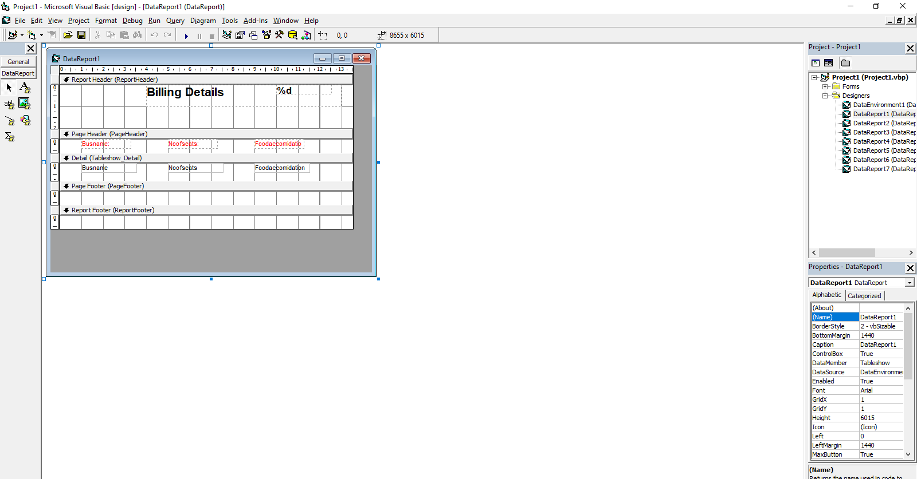

* + 1. DATA REPORT 2 (BUS ROUTE DETAILS)

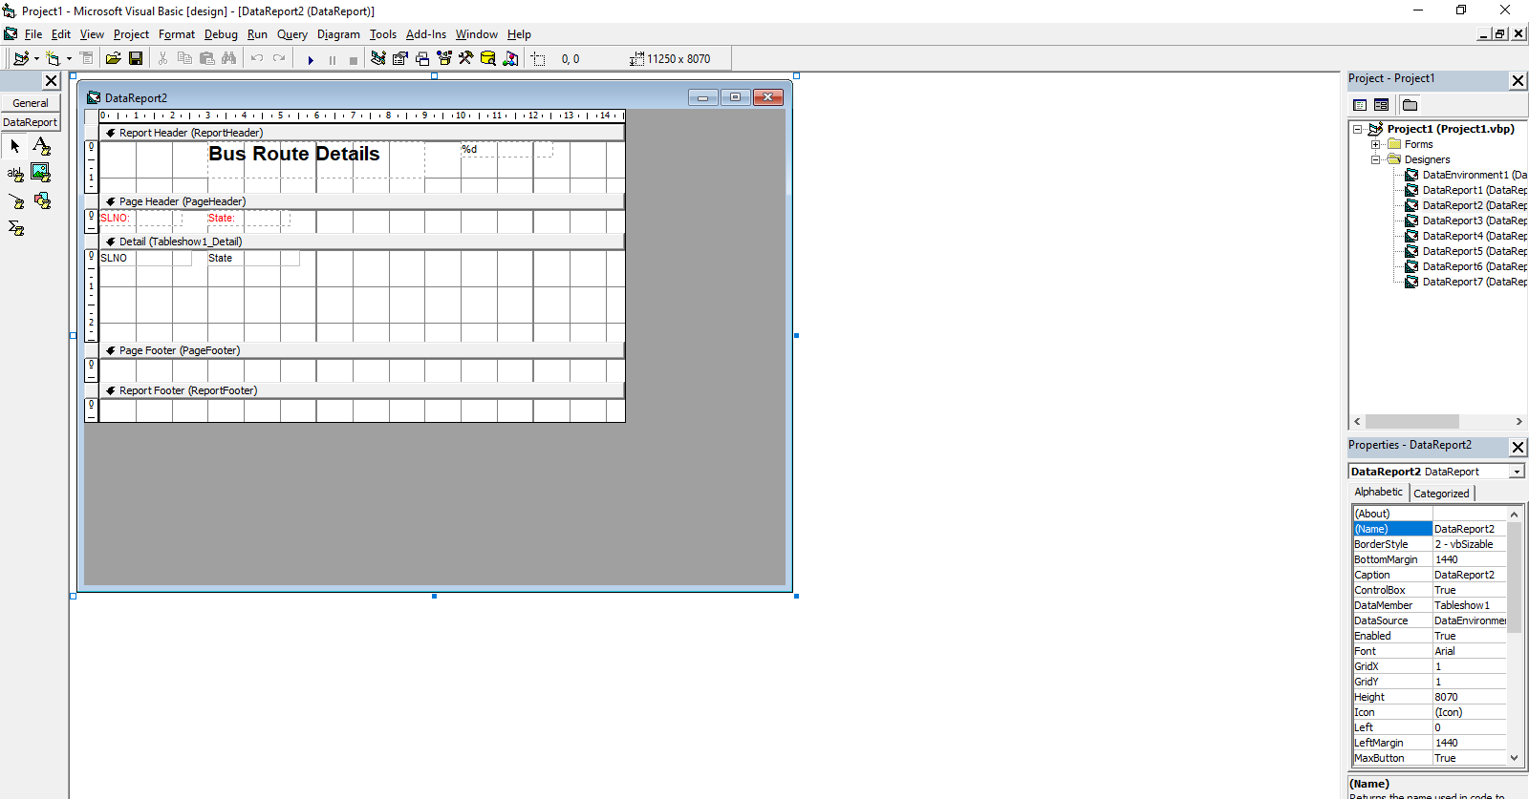

* + 1. DATA REPORT 3 (ENQUIRY DETAILS)

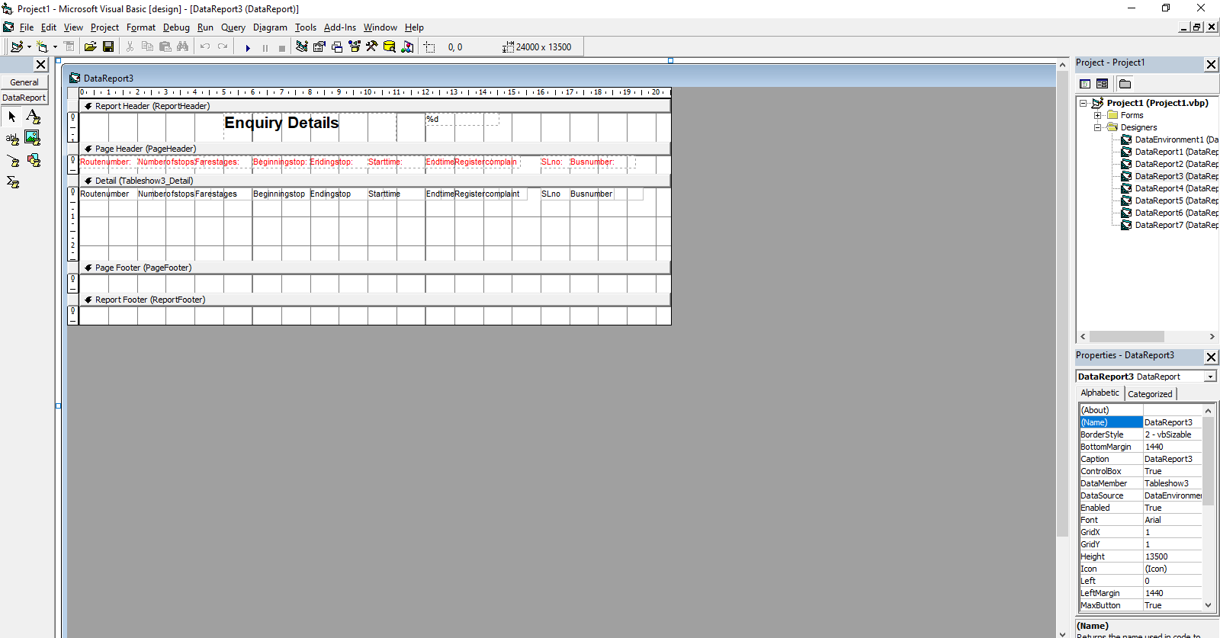

* + 1. DATA REPORT 4 (LOGIN DETAILS)

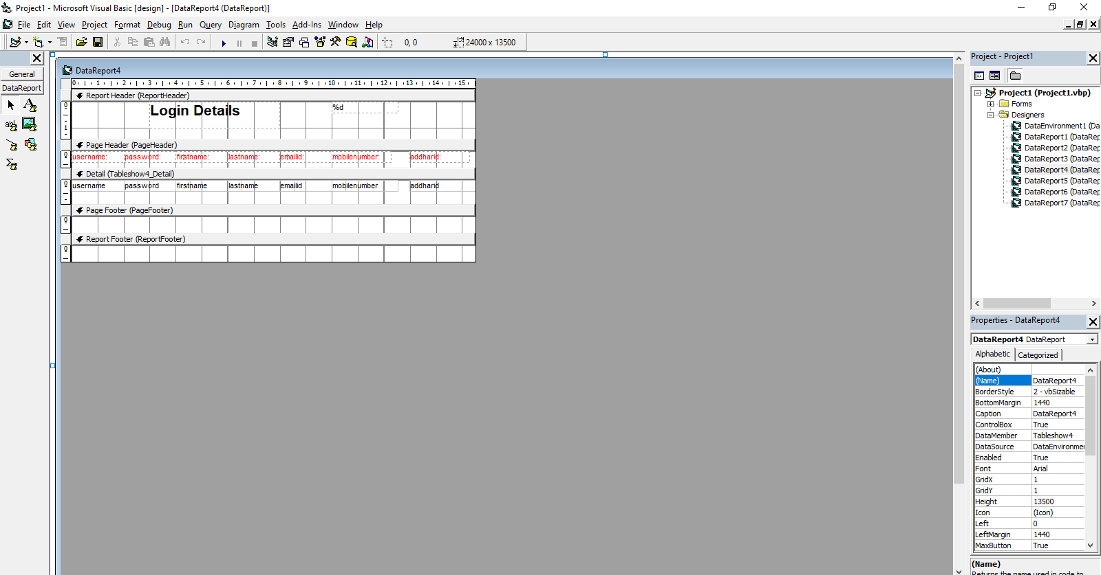

* + 1. DATA REPORT 5 (AMOUNT FORMS)

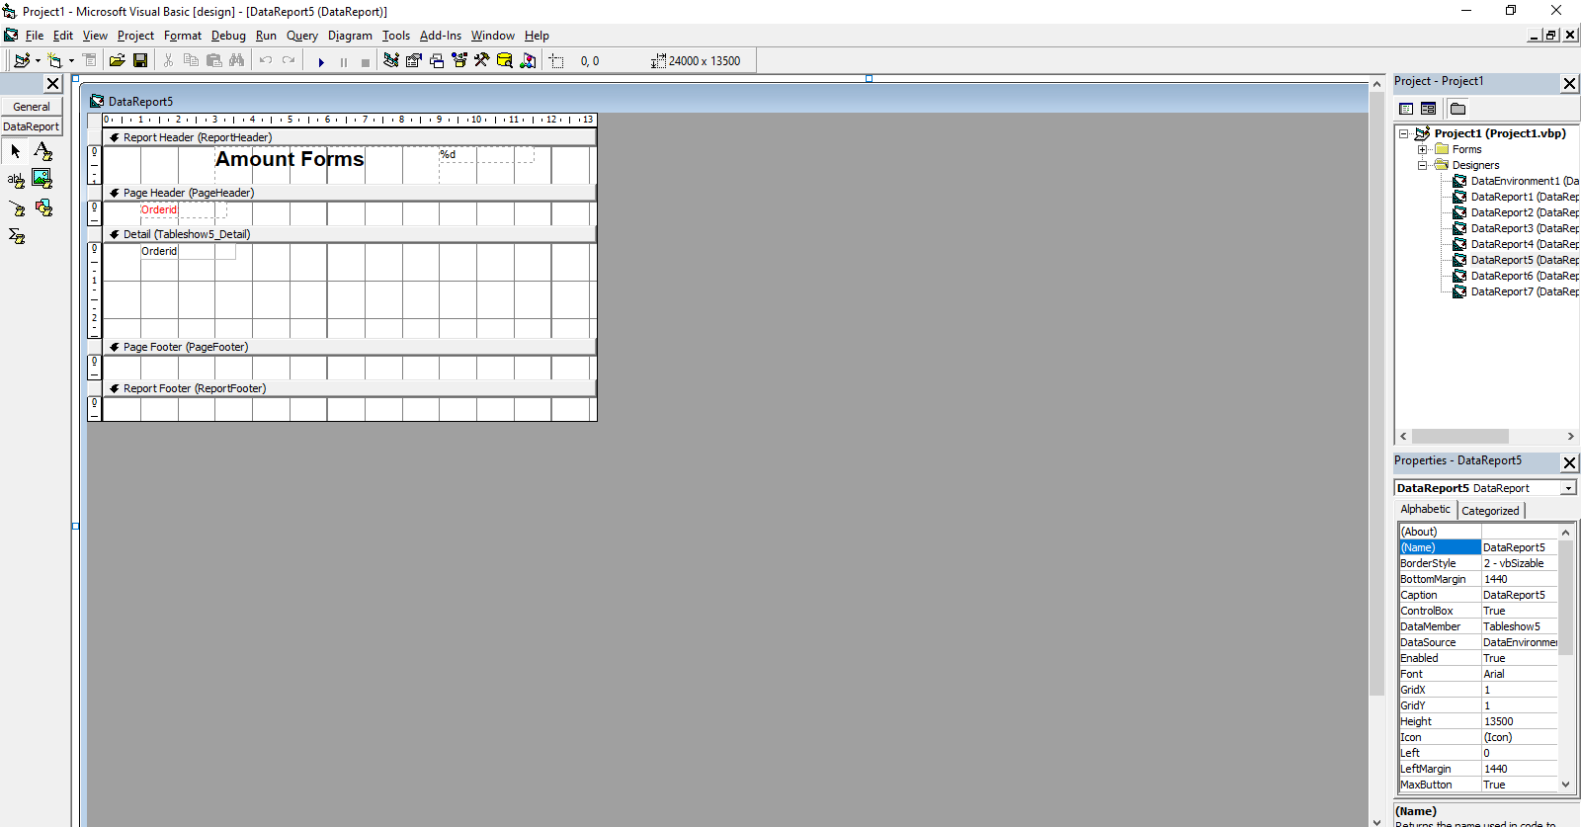

* + 1. DATA REPORT 6 (NET BANKING DETAILS)

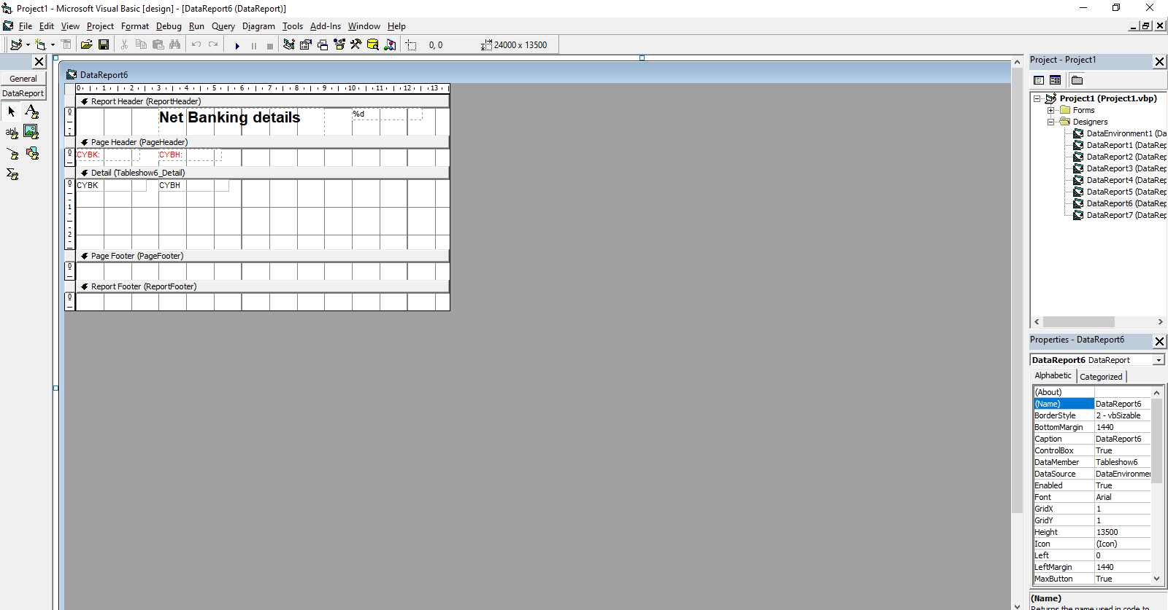

* + 1. DATA REPORT 7 (COST OF CHILD AND ADULT)

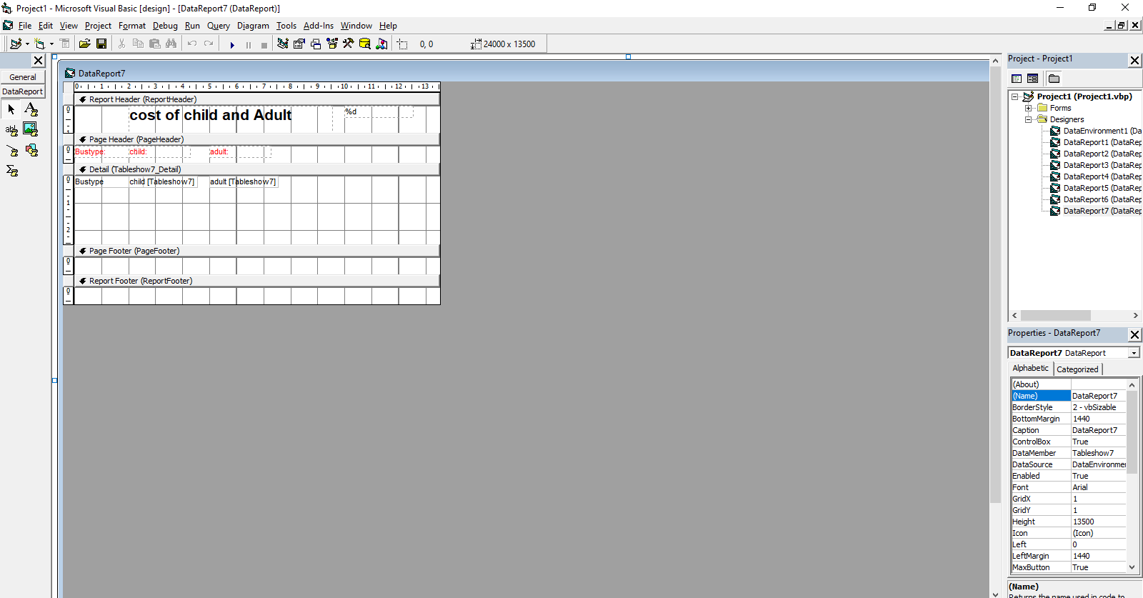

**CHAPTER – 5**

**SYSTEM TESTING**

The aim of the system testing process was to determine all defects in our project. The program was subjected to a set of test inputs and various observations were made and based on these observations it will be decided whether the program behaves as expected or not.

Our Project went through two levels of testing

1. Unit testing

2. integration testing

**UNIT TESTING**

Unit testing is undertaken when a module has been created and successfullyreviewed. In orderto test a single module, we need to provide a complete environment i.e. besides the module we would require

* The procedures belonging to other modules that the module under test calls
* Non local data structures that module accesses
* A procedure to call the functions of the module under test withappropriate parameters. Unit testing was done on each and every module that is described under module description of chapter 4

**INTEGRATION TESTING**

In this type of testing we test various integration of the project module by providing the input.

The primary objective is to test the module interfaces in order to ensure that no errors are occurring when one module invokes the other module.

Integration testing is systematic technique for constructing the program structure while at the same time conducting tests to uncover errors associated with interfacing. The objective is to take unit tested components and build a program structure that has been dictated by design.

The entire program is tested as whole. Correction is difficult because isolation of causes is complicated by vast expanse of entire program. Once these errors are corrected, new ones appear and the process continues in a seemingly endless loop. After unit testing in Sell-Soft System all the modules were integrated to test for any inconsistencies in the interfaces. Moreover differences in program structures were removed and a unique program structure was evolved.

**CHAPTER – 6**

**CONCLUSION AND FUTURE SCOPE**

**CONCLUSION**

Online Bus Ticket Reservation is a system where bus users can reserve their seats using a web-based application. It is made for the ease of access for both the bus trip administrators and the bus users. It maintains all customer details, their bus information which includes their bus route, bus seat, bus trip arrival time, bus trip destination time, and bus fare. To gather data, the researchers use Google Forms since it is not possible for the researchers to gather data physically since there is a pandemic which hinders the researchers from going outside. The application achieved is capable of checking the reservations made by a certain person which includes their personal information and bus seat reservation information. Despite the existence of the application, there is still a need for usage of Email for sending the confirmation email and also for the ticket which can be presented to the person-in-charge of the bus trip on the day of the trip. This study is conducted to see if there is an impact on the bus users if instead of going to the bus companies themselves to reserve a bus seat, they can reserve the bus seats online and also to determine what options do passengers need when it comes to an improved bus reservation system.

**FUTURE SCOPE**

The scope of IT ticketing systems is **widespread, with applications in different kinds of businesses, large and small, that have an IT support team or a customer support team that works on IT issues and service requests**.

**CHAPTER – 7**

**REFERENCES**

* [www.google.com](http://www.google.com)
* [www.slideshare.com](http://www.slideshare.com)
* [www.programiz.com](http://www.programiz.com)
* [www.w3schools.com](http://www.w3schools.com)

skyward publishers, Visual Programming textbook, Author (Padmageetha B.G, Srikanth. S)

**SCREENSHOTS OF BUS RESERVATION SYSTEM**

**SPLASH FORM**

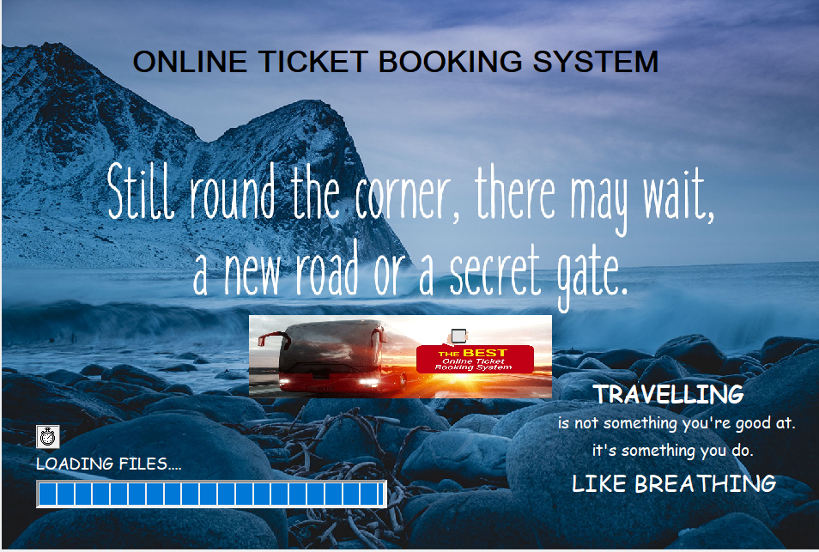

**LOGIN FORM**

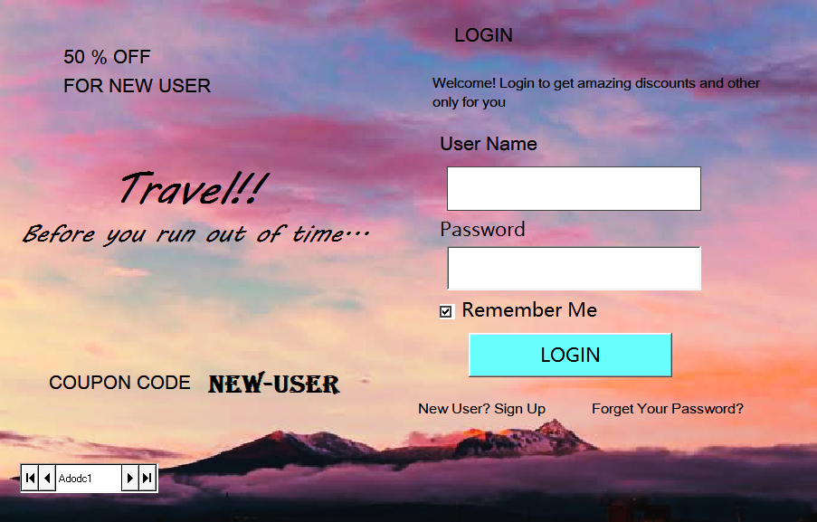

**REGISTER FORM**

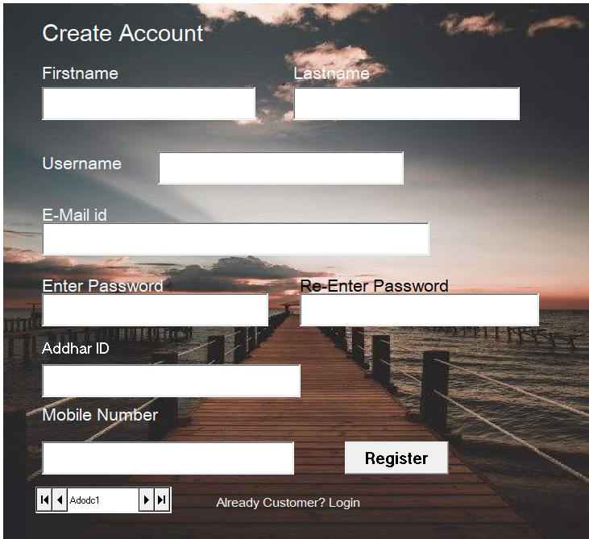

**MDI FORM**

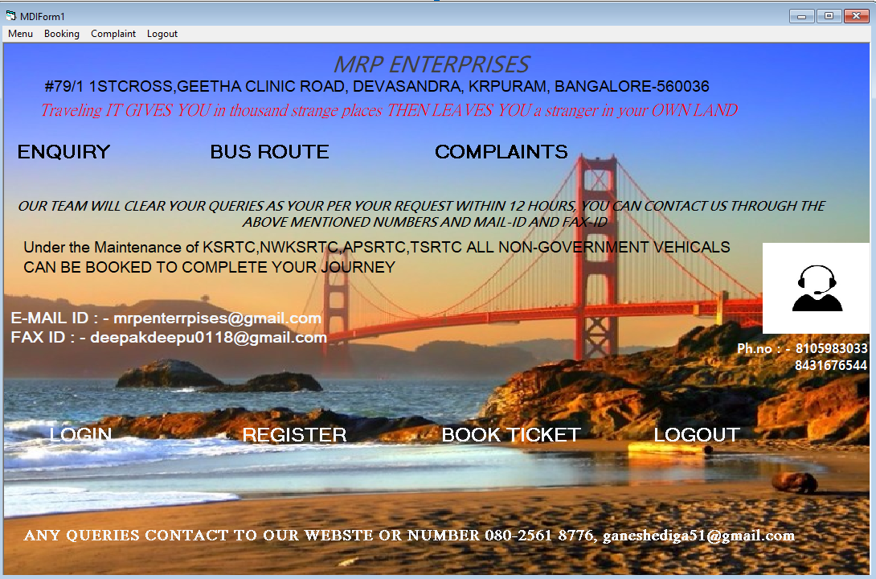

**COMPLAINT FORM**

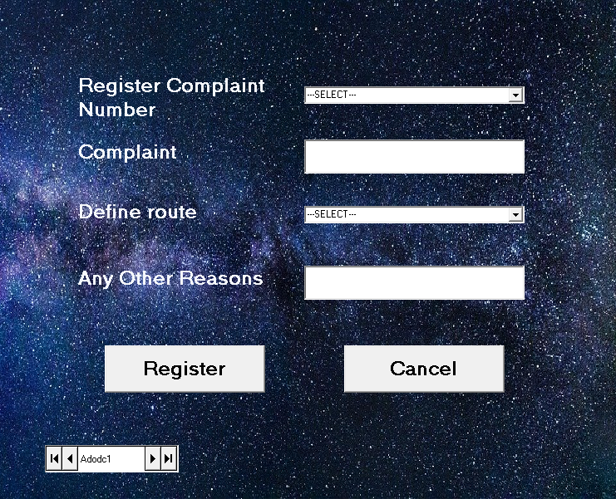

**BUS ROUTE FORM**

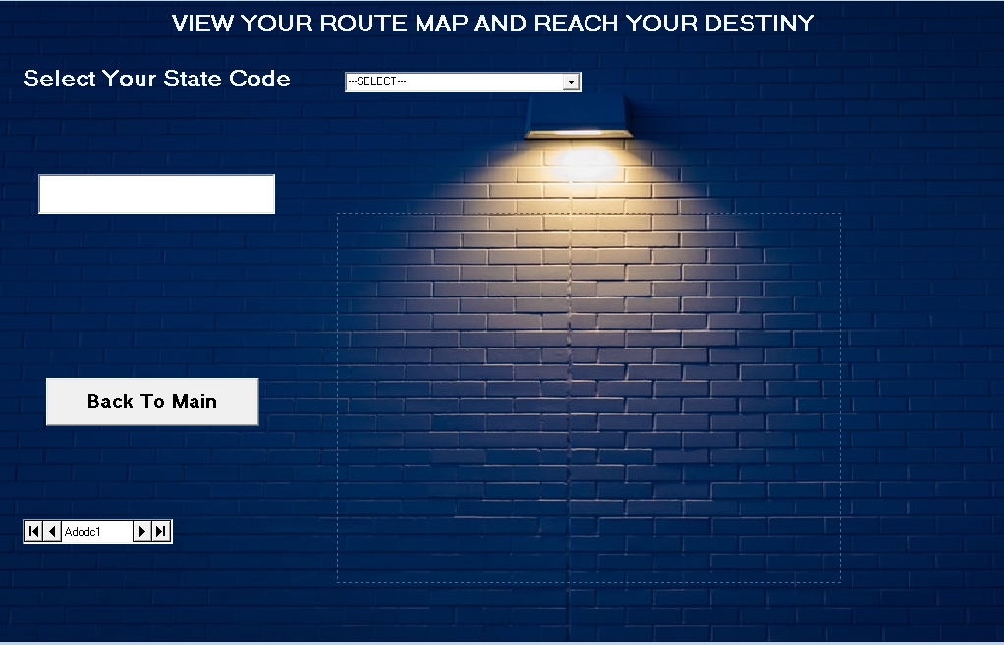

**ENQUIRY DETAILS FORM**

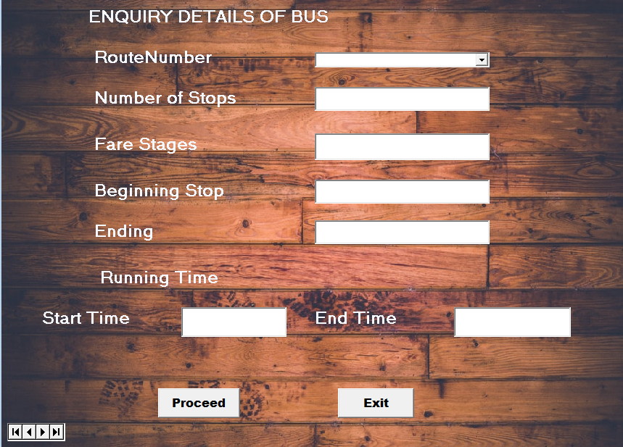

**TICKETING FORM**

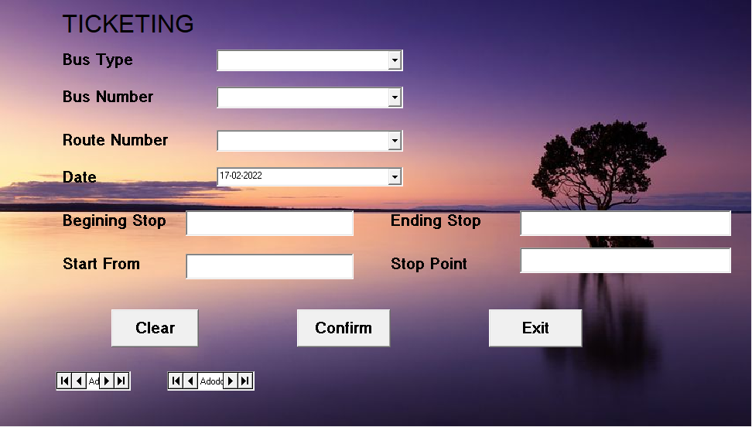

**BILLING FORM**

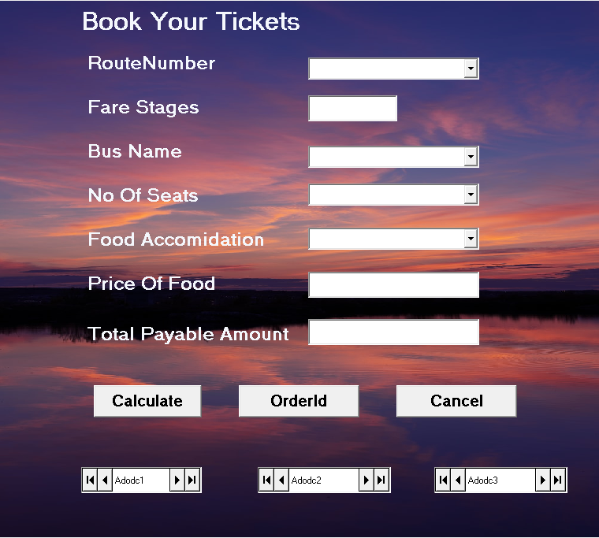

**BILL FORM**

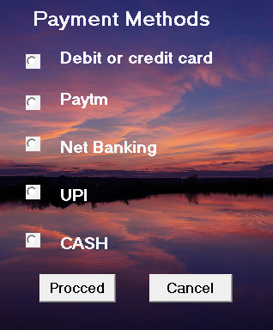

**DEBIT AND CREDIT PAYMENT FORM**

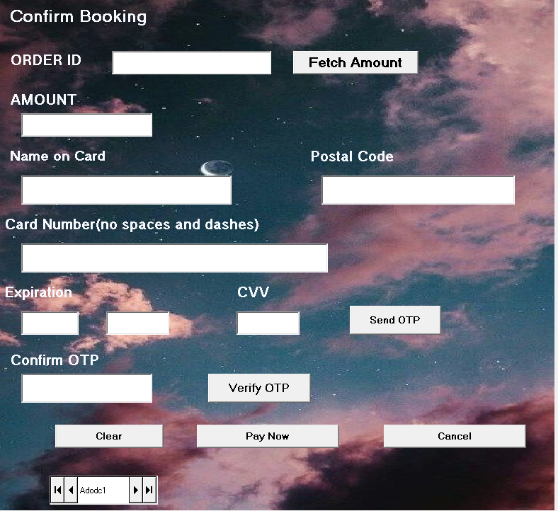

**PAYTM PAYMENT FORM**

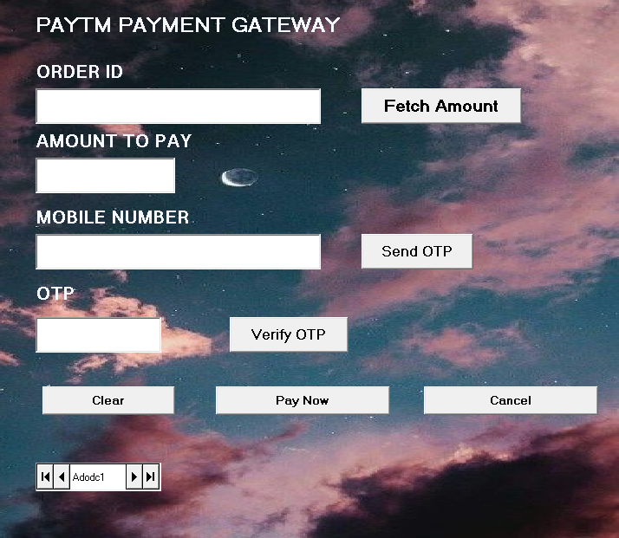

**UPI PAYMENT FORM**

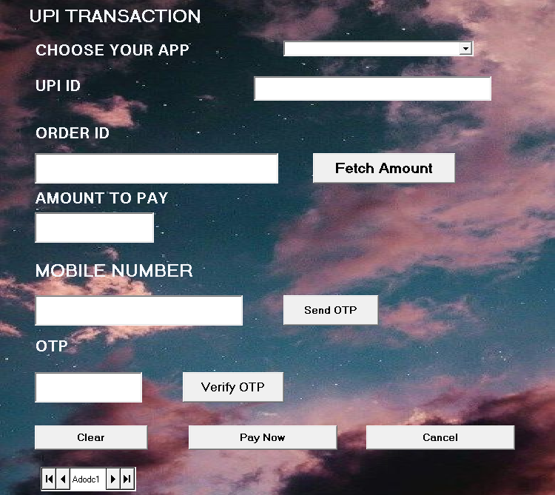

**NET BANKING FORM**

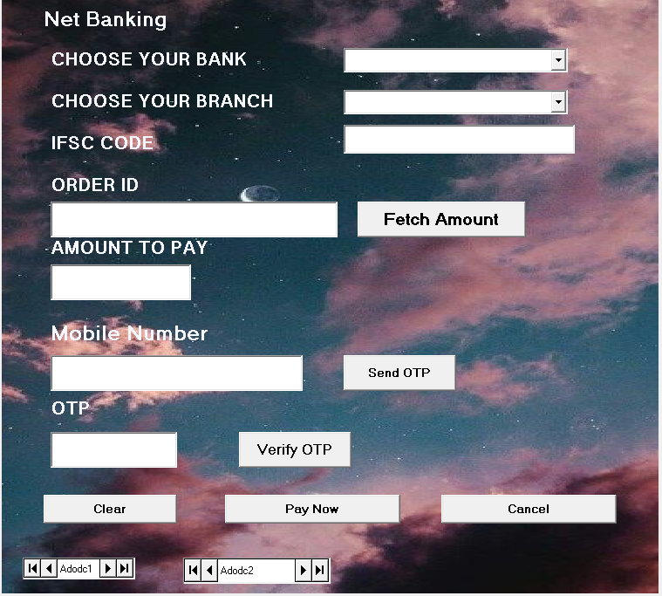

**REPORT FORM**

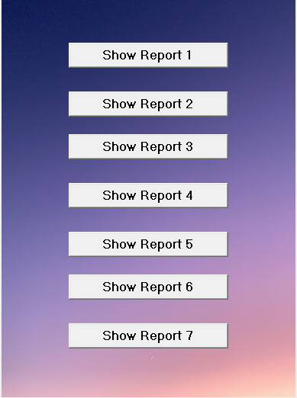

**LOGOUT FORM**

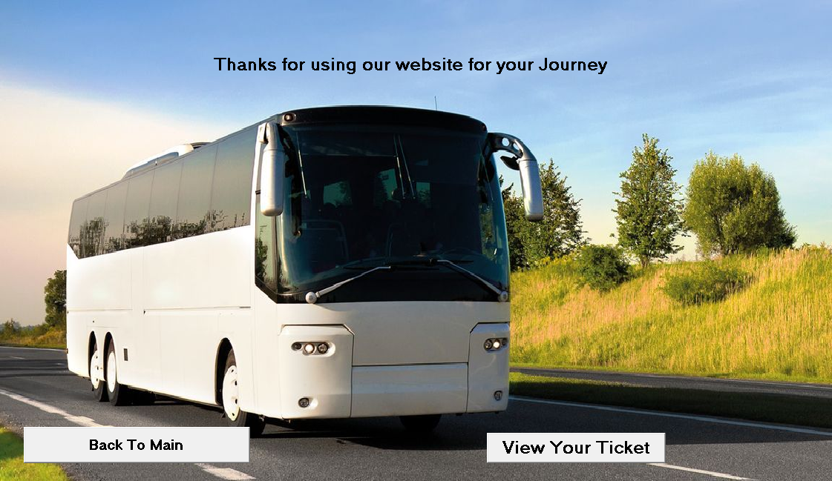

**PRINT FORM**

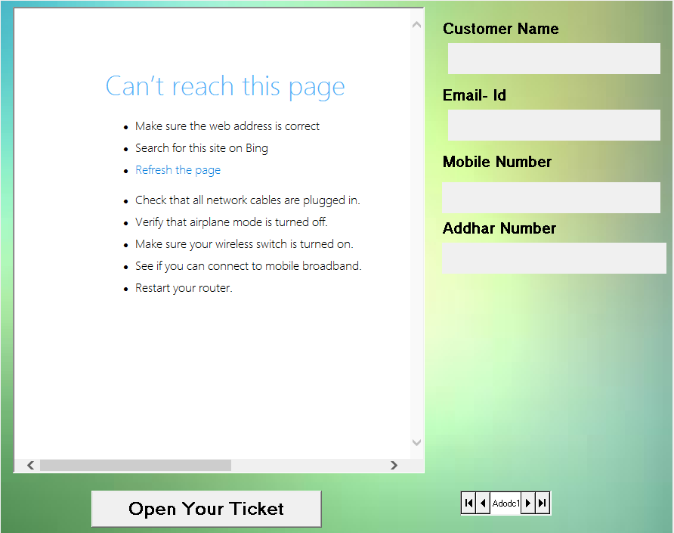

**CONCLUSION**

The project entitled “BUS TICKET RESERVATION SYSTEM” has been proposed to be implementing to replace the manual system.

1. The developed system accomplishes all the objectives stated for the change of the system.
2. The outputs produced seem to satisfy all the users but it will definitely take to look forwarded for the real consequences the new system could produce.
3. This project was made user friendly by the use of VB 6.0 enabling the user to interact easily with the database.
4. This is achieved through an easy to use graphical interface menu options. The users can add to cart button for each item. Once item is added to the cart, user is presented with detailed order to review or continue shopping.
5. The objective of software planning is to provide a frame work that enables at the beginning of the software project and should be updated regularly as the project progresses.

**FUTURE ENCHANCEMENT**

This project can be handled in future by doing various modifications like –

1. We can give more advance software for MAYURI ONLINE LIBRARY System including more facilities.
2. We will host the platform on online servers to make it accessible worldwide.
3. Integrate multiple load balancers to distribute the loads of the system.
4. Create the master and slave database structure to reduce the overload of the database queries.
5. Implement the backup mechanism for taking backup of codebase and database on regular basis on different servers.

**BIBILOGRAPHY**

[www.google.com](http://www.google.com)

[www.wikipedia.com](http://www.wikipedia.com)

[www.slideshare.com](http://www.slideshare.com)